Univariate plots of Yaounde COVID study data

2020-12-15

# 1 Administration of questionnaire

## 1.1 Is this the original sampled household?

(per household)

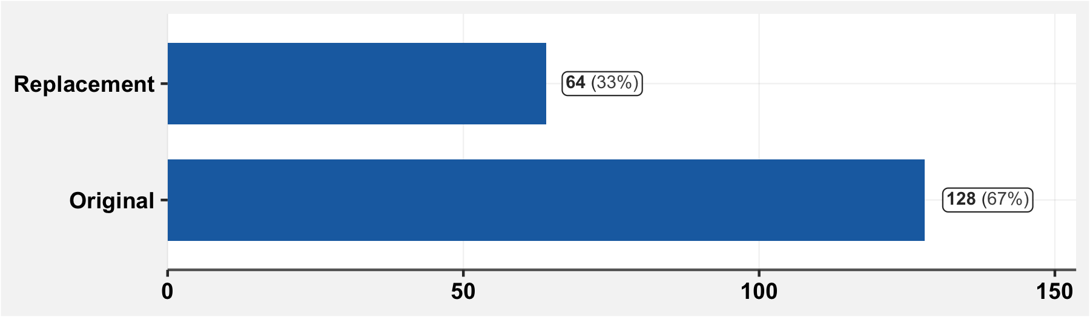

**NOTE** It is not clear to me whether 0 means “original” or “replacement”.

## 1.3 Which surveyors administered the questionnaire?

(per respondent)

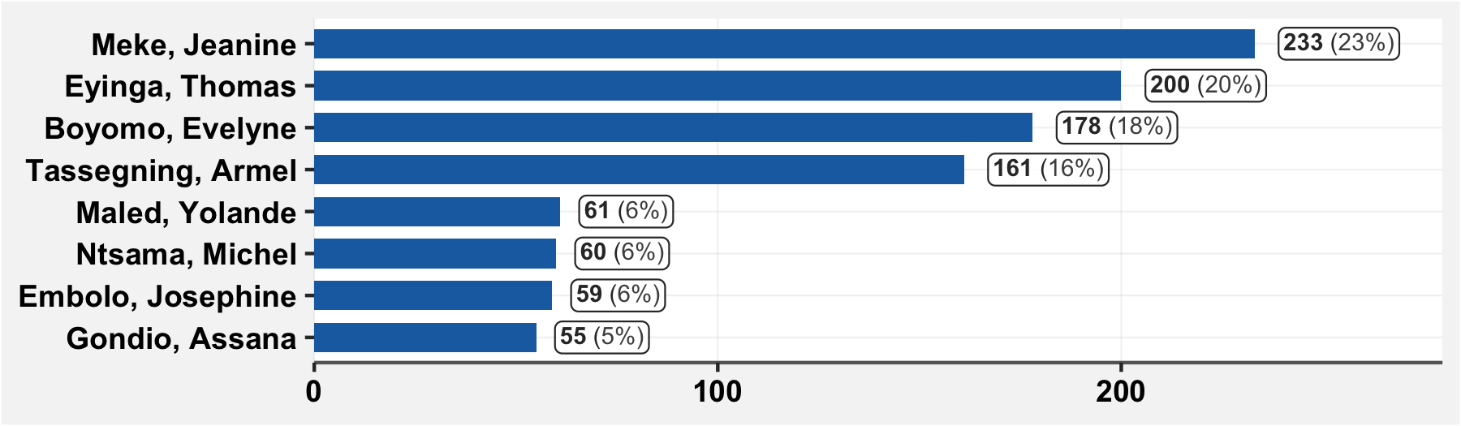

## 1.4 Date of survey completion

(per respondent)

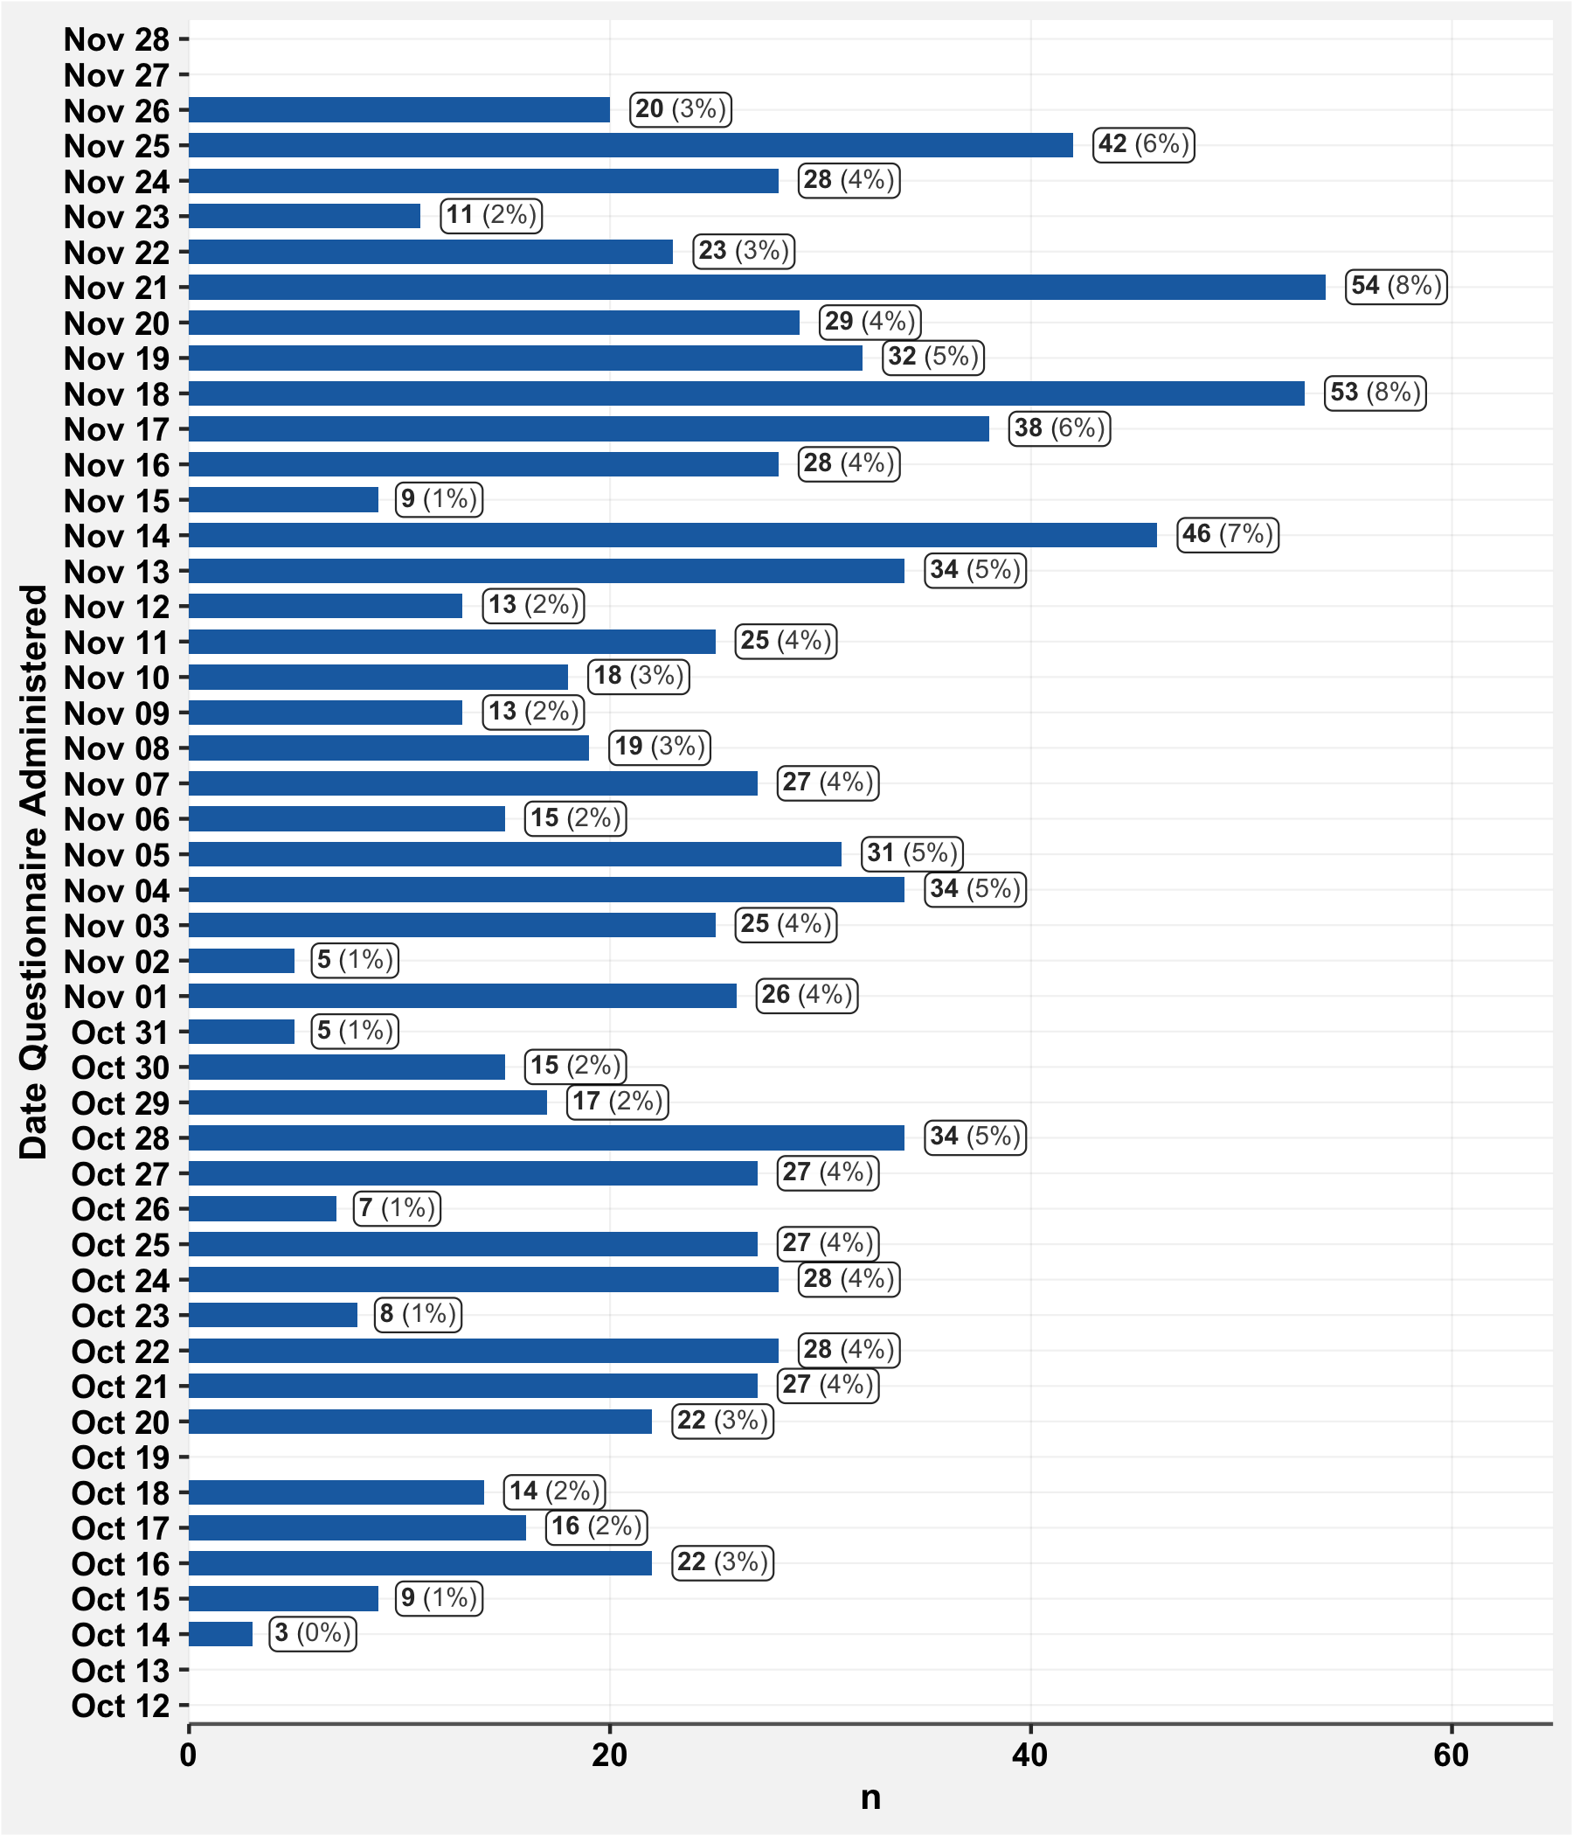

## 1.5 City Area

(per household)

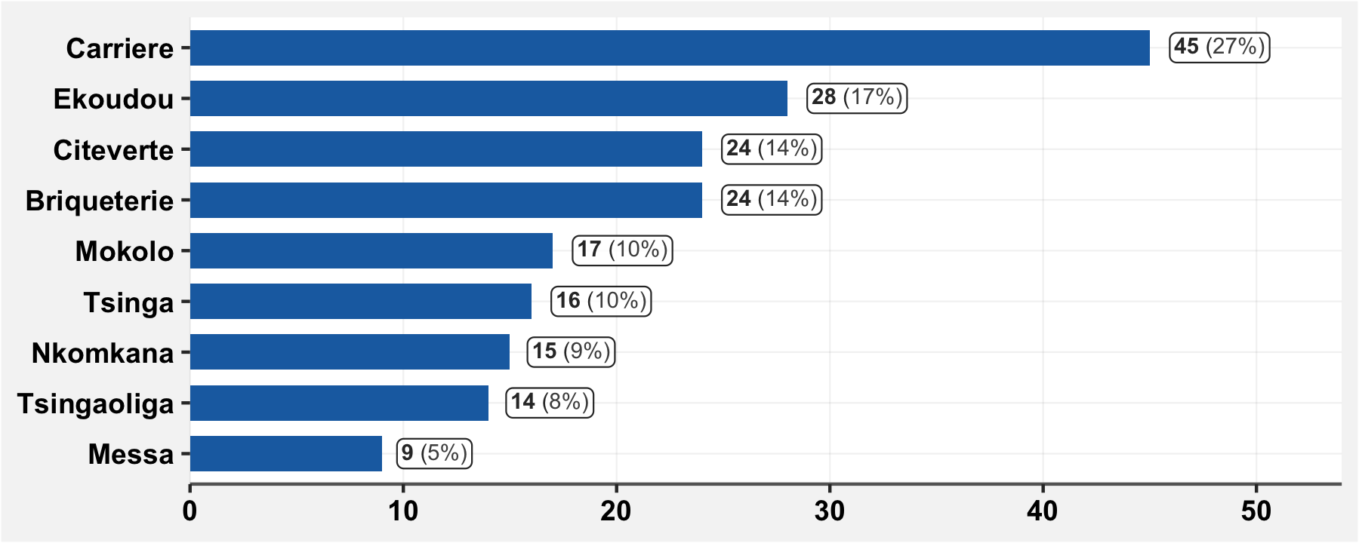

# 2 Household Composition

All variables below are per household. The answers from a single representative individual are taken to represent the information about the household.

This representative individual is either:

* The first “household head” to be interviewed in a household; or
* In cases where there is no head, the first individual above 18 to be interviewed in the household.

## 2.2 GPS location

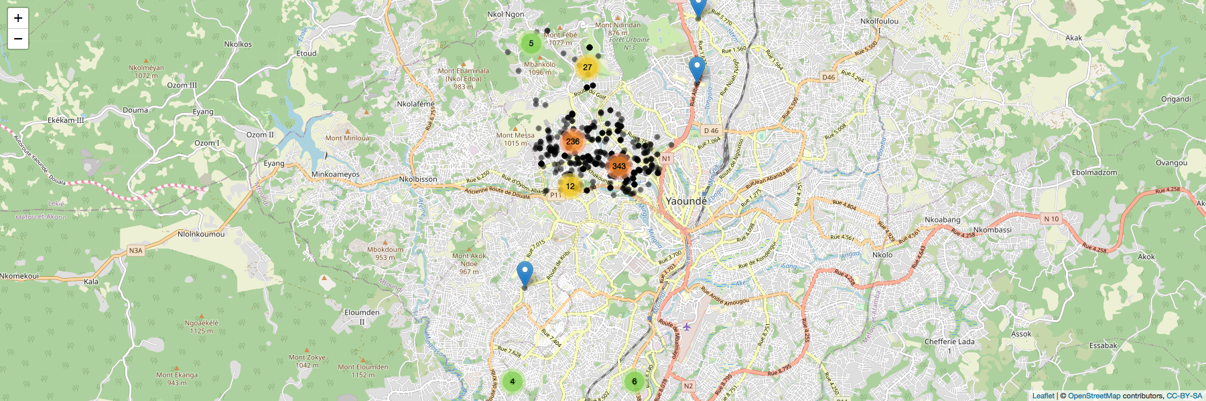

NOTE The map above is a screenshot of an interactive web map. See the html version of this report to access map

## 2.3 Number of rooms

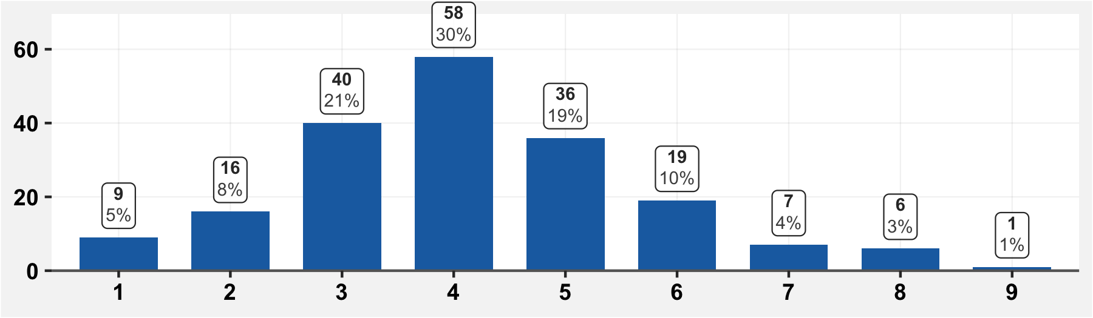

## 2.4 Number of adults

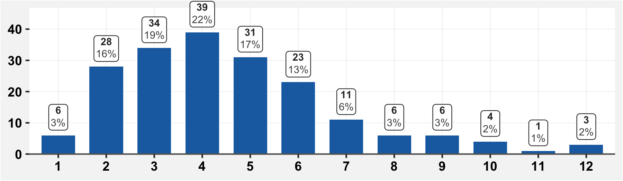

## 2.5 Number of children

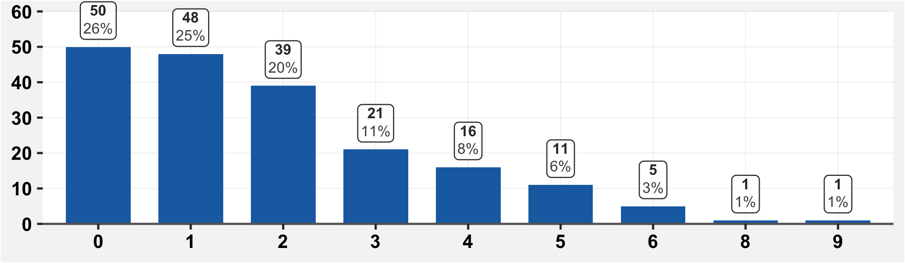

## 2.7 Have there been deaths in the household since March 1st?

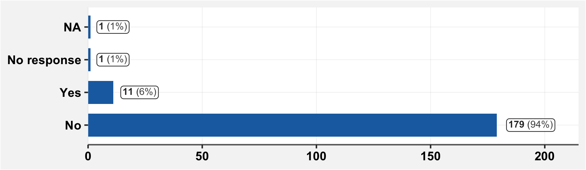

**NOTE** Here, NA means the cell was completely blank. NR means it was filled in as “Ne repond pas”

## 2.7.1 If there have been deaths in the household since March 1st, specify

All deaths reported are shown in the table below. No household had more than one death.

|  |  |  |  |
| --- | --- | --- | --- |
| **Date of Death** | **Sex** | **Age at Death** | **Cause of Death** |
| Oct 11 | M | 83 | Unspecified |
| Aug 25 | F | 67 | Diabetes |
| May 01 | M | 50 | Cardiac arrest |
| Apr 05 | M | 50 | Stroke |

# 3 Information about the household

## 3.1 Are you the “Chef du menage”?

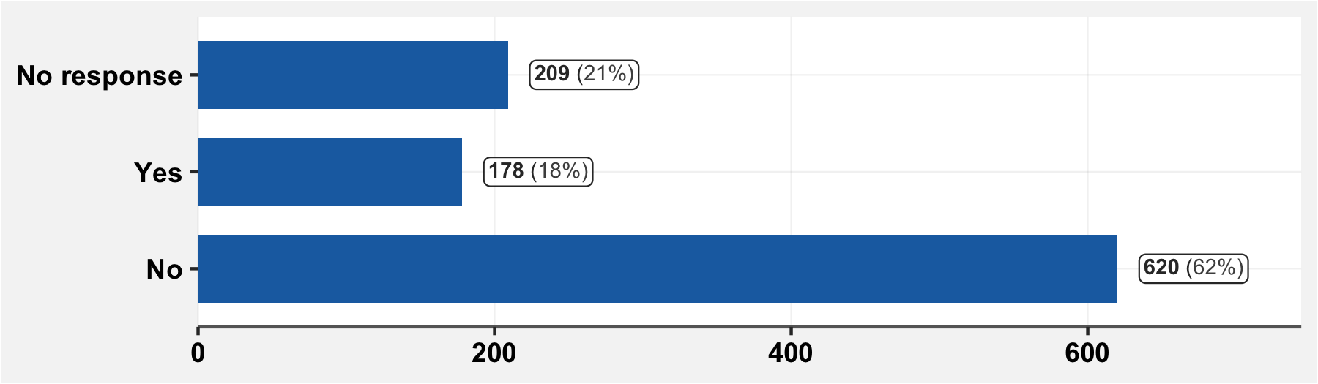

## 3.2 Are you the principal breadwinner in the household?

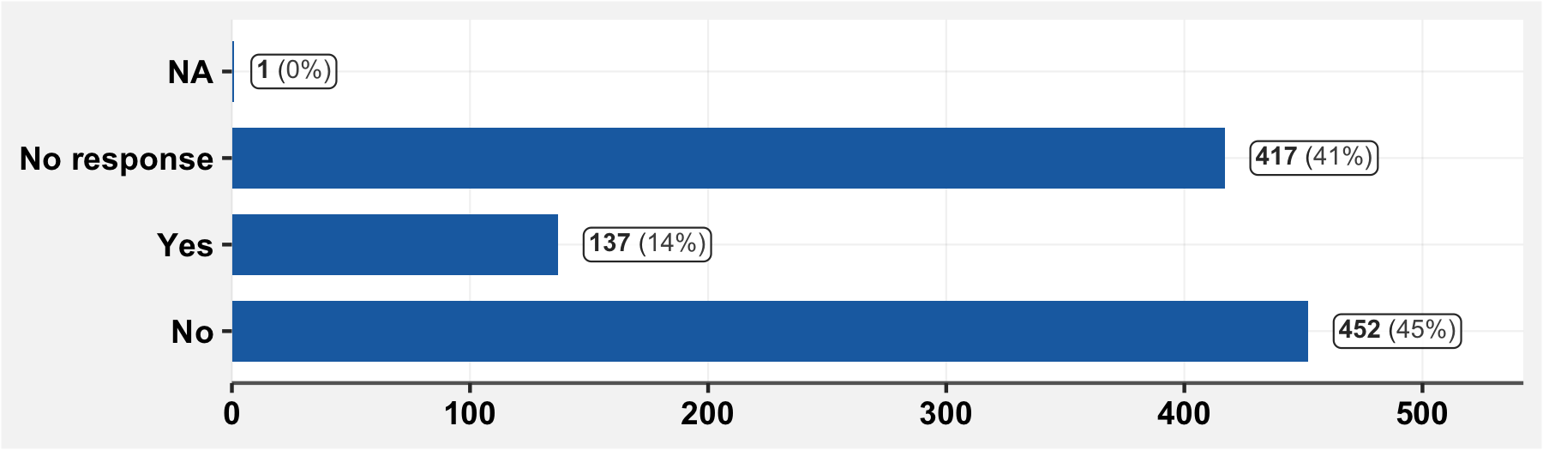

## 3.3 Who is the principal breadwinner in the household?

(Only answers from household representatives are shown.)

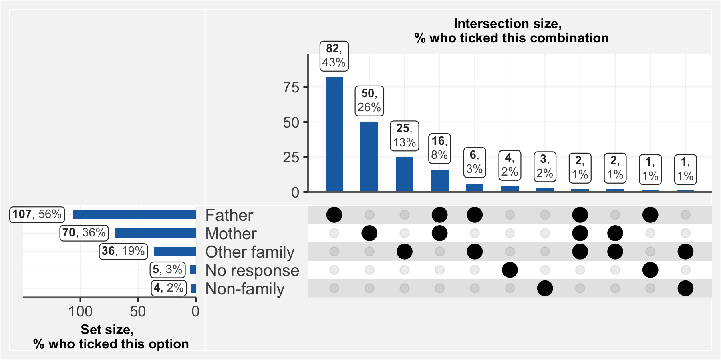

## 3.4 What are the revenue sources of the family?

(Only answers from household representatives are shown.)

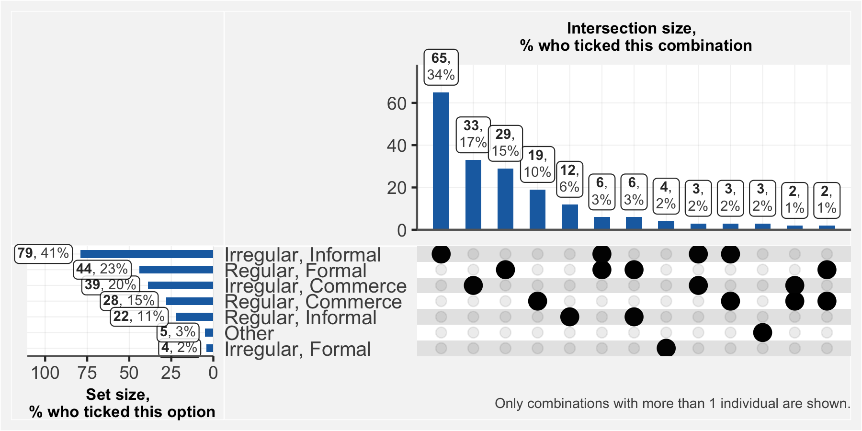

## 3.4.1 If you answered “Other” to the previous question, specify

(Only answers from household representatives are shown.)

|  |  |
| --- | --- |
| **Other income source** | **n** |
| Diaspora | 3 |
| Cultivatrice | 1 |
| Inapproprie | 1 |

## 3.5 Since March 1st, has the revenue of the household diminished?

(Only answers from household representatives are shown.)

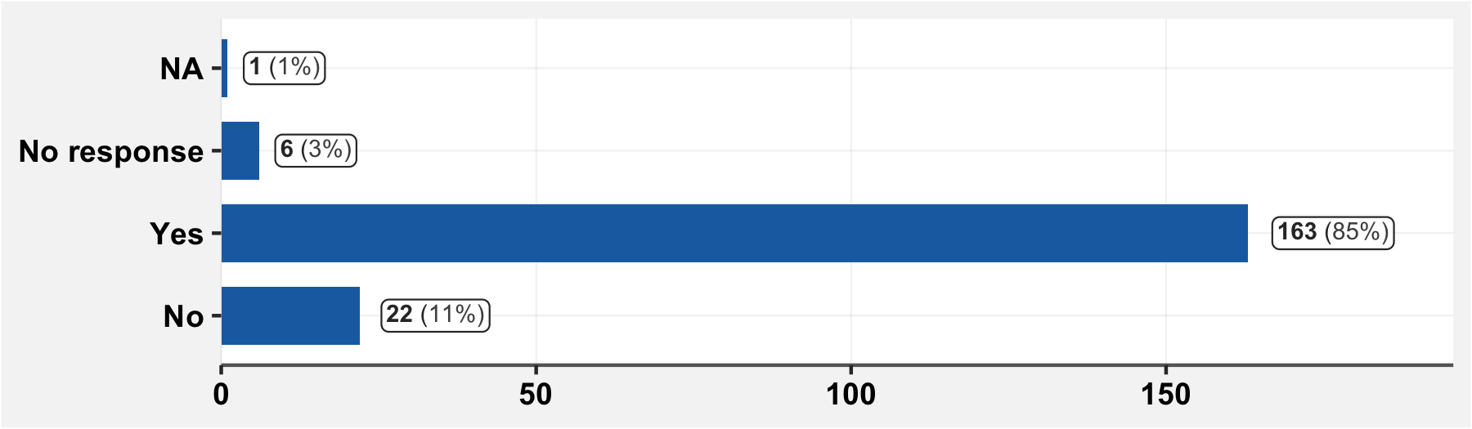

## 3.6 Has a household member lost their job or had their working hours reduced?

(Only answers from household representatives are shown.)

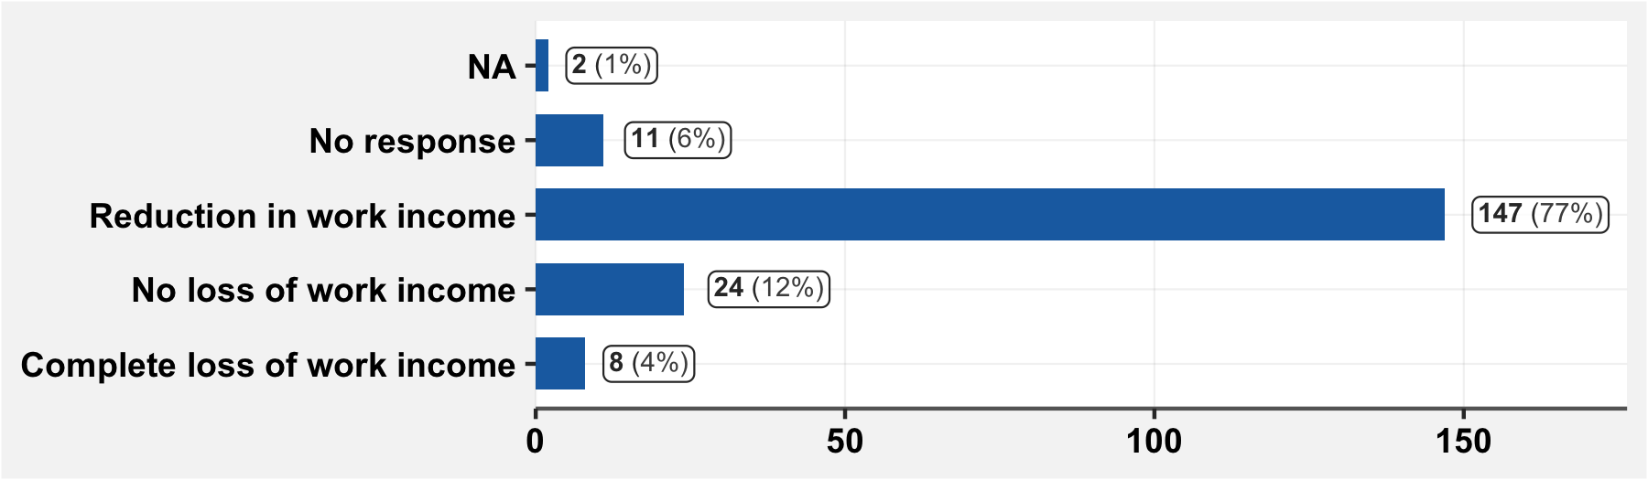

## 3.7 Has a household member tested positive for COVID-19?

(Only answers from household representatives are shown.)

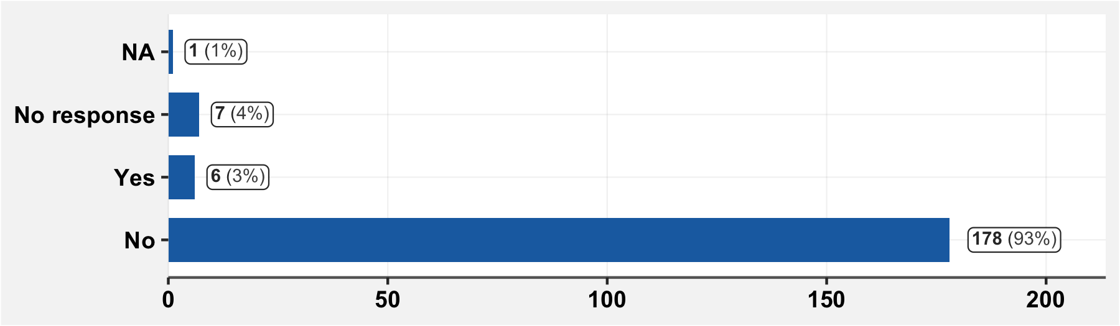

## 3.7.1 If a household member has tested positive for COVID-19, specify

(Only answers from household representatives are shown.)

|  |  |  |
| --- | --- | --- |
| **Date of Test** | **Age** | **Sex** |
| 2020-06-10 | 50 | F |
| 2020-10-04 | 48 | F |
| 2020-04-15 | 46 | H |
| 2020-07-01 | 70 | F |
| 2020-05-15 | 51 | M |

# 4. Socio-administrative information about the surveyed individual

## 4.1 Sex

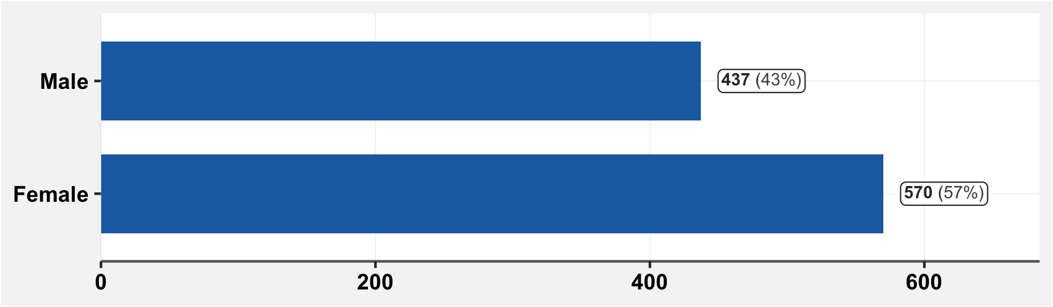

## 4.2 Age

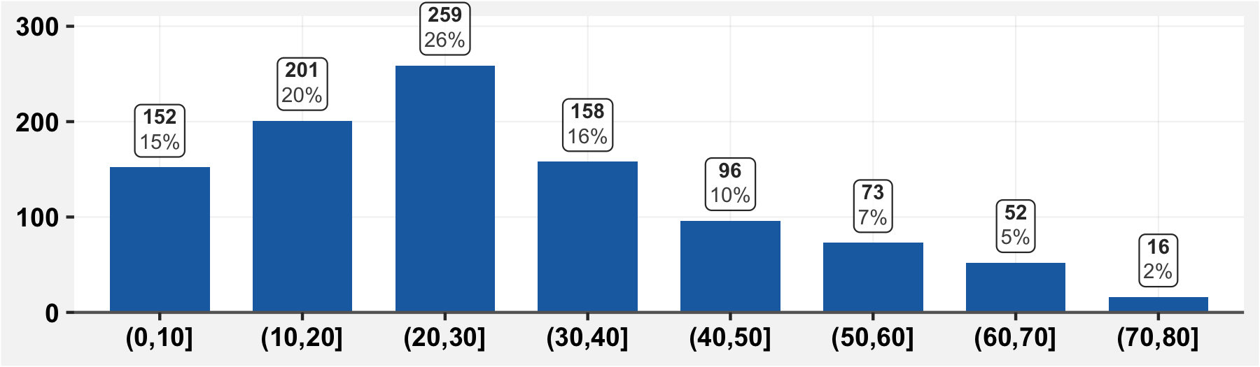

## 4.3 Date of birth

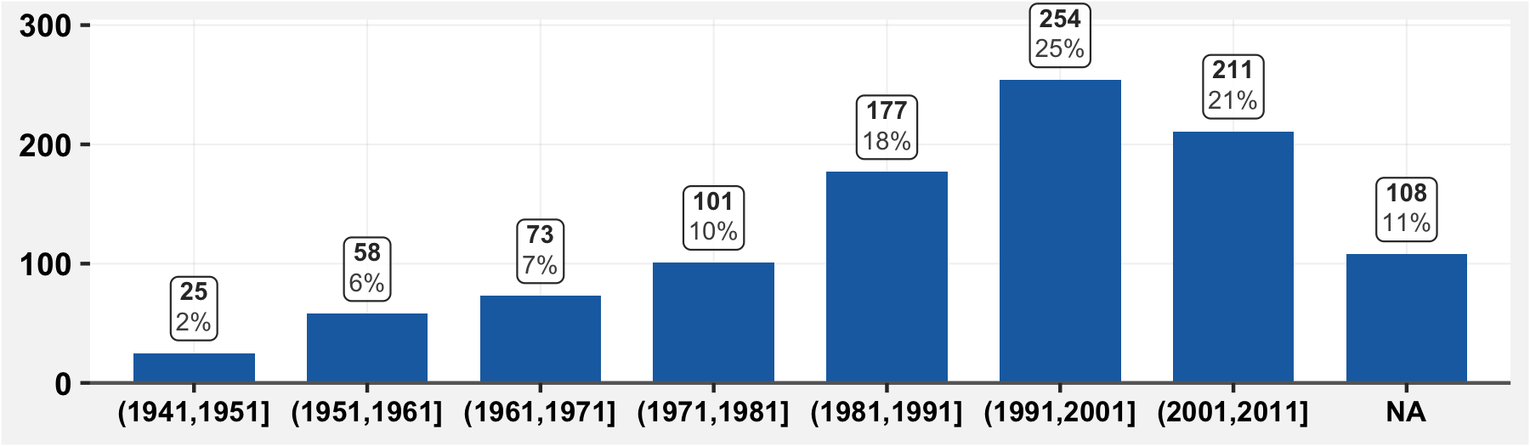

## 4.4 Education level

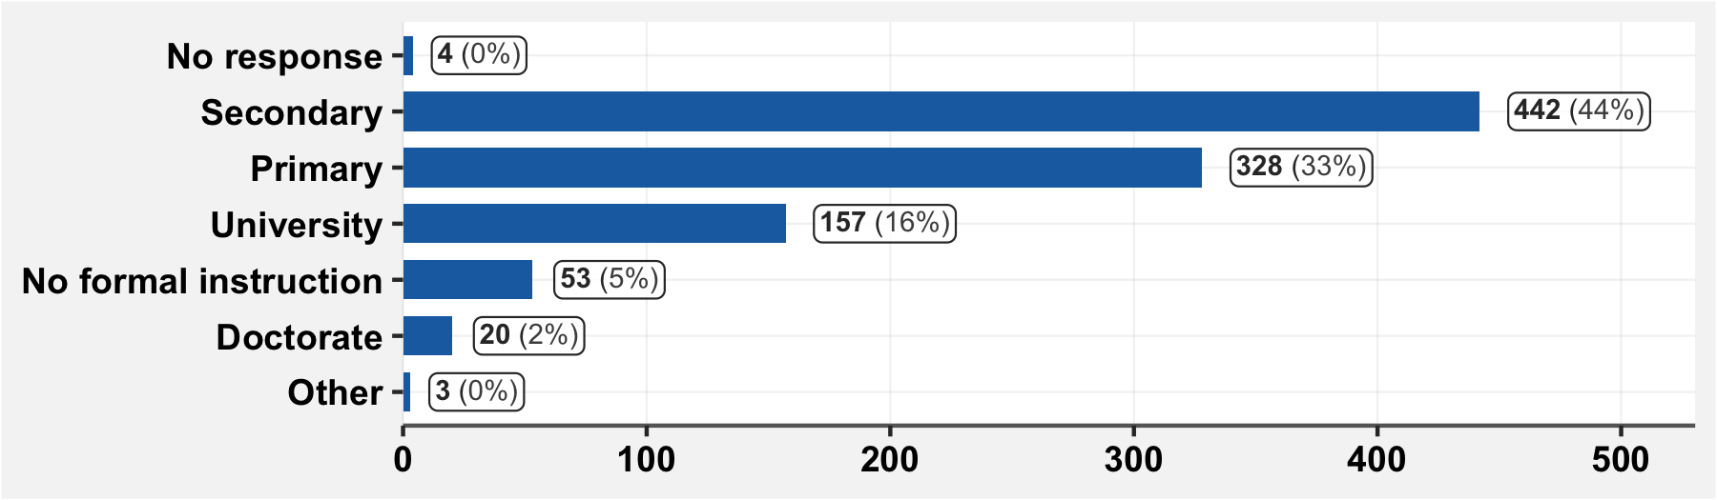

## 4.5 “Are you currently a…” (occupation)

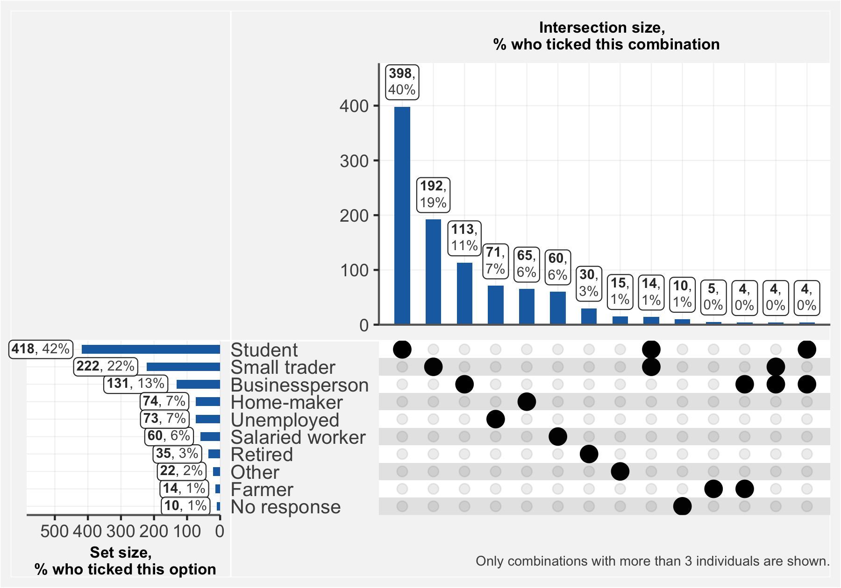

## 4.5.1 If you answered “Other” to the previous question, specify

|  |  |
| --- | --- |
| **Other occupation** | **n** |
| Eleve | 7 |
| Transporteur | 2 |
| Agent Communal | 1 |
| Consultant Expert Comptable | 1 |
| Couturiere | 1 |
| Elevage | 1 |
| Eleveur | 1 |
| Enseignant | 1 |
| Estheticienne | 1 |
| Infirmiere | 1 |
| Rien | 1 |
| Taximen | 1 |

# 5. Symptoms suggestive of COVID-19

## 5.1 Since the 1st of March, have you had one or several of the following symptoms?

All respondents:

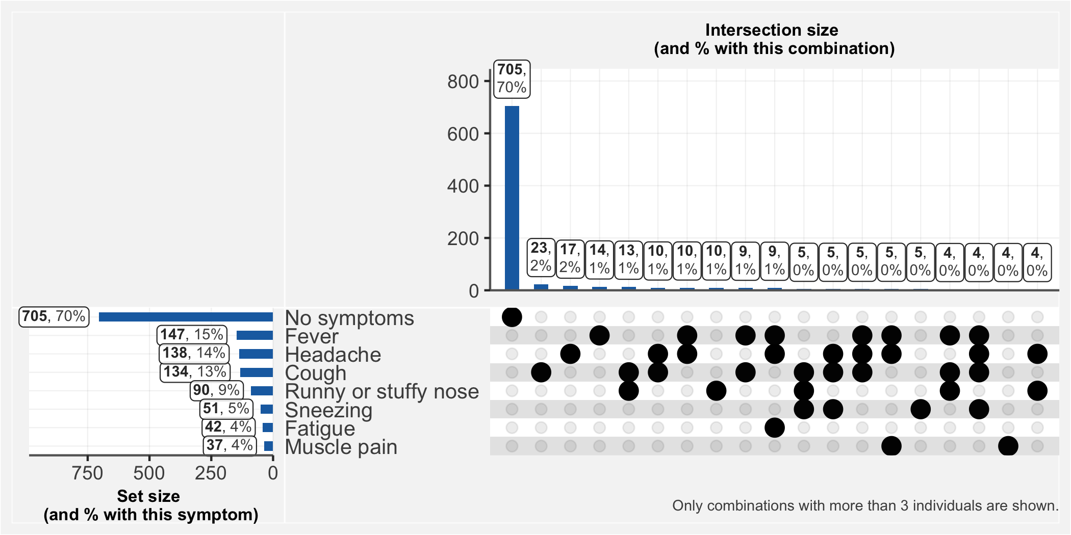

Subset of those who have had symptoms:

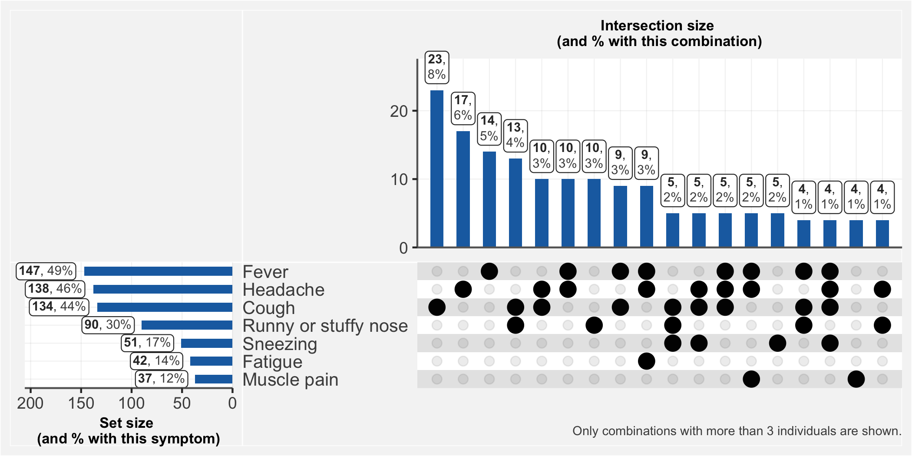

Subset of those who had a positive IgG or IgM test:

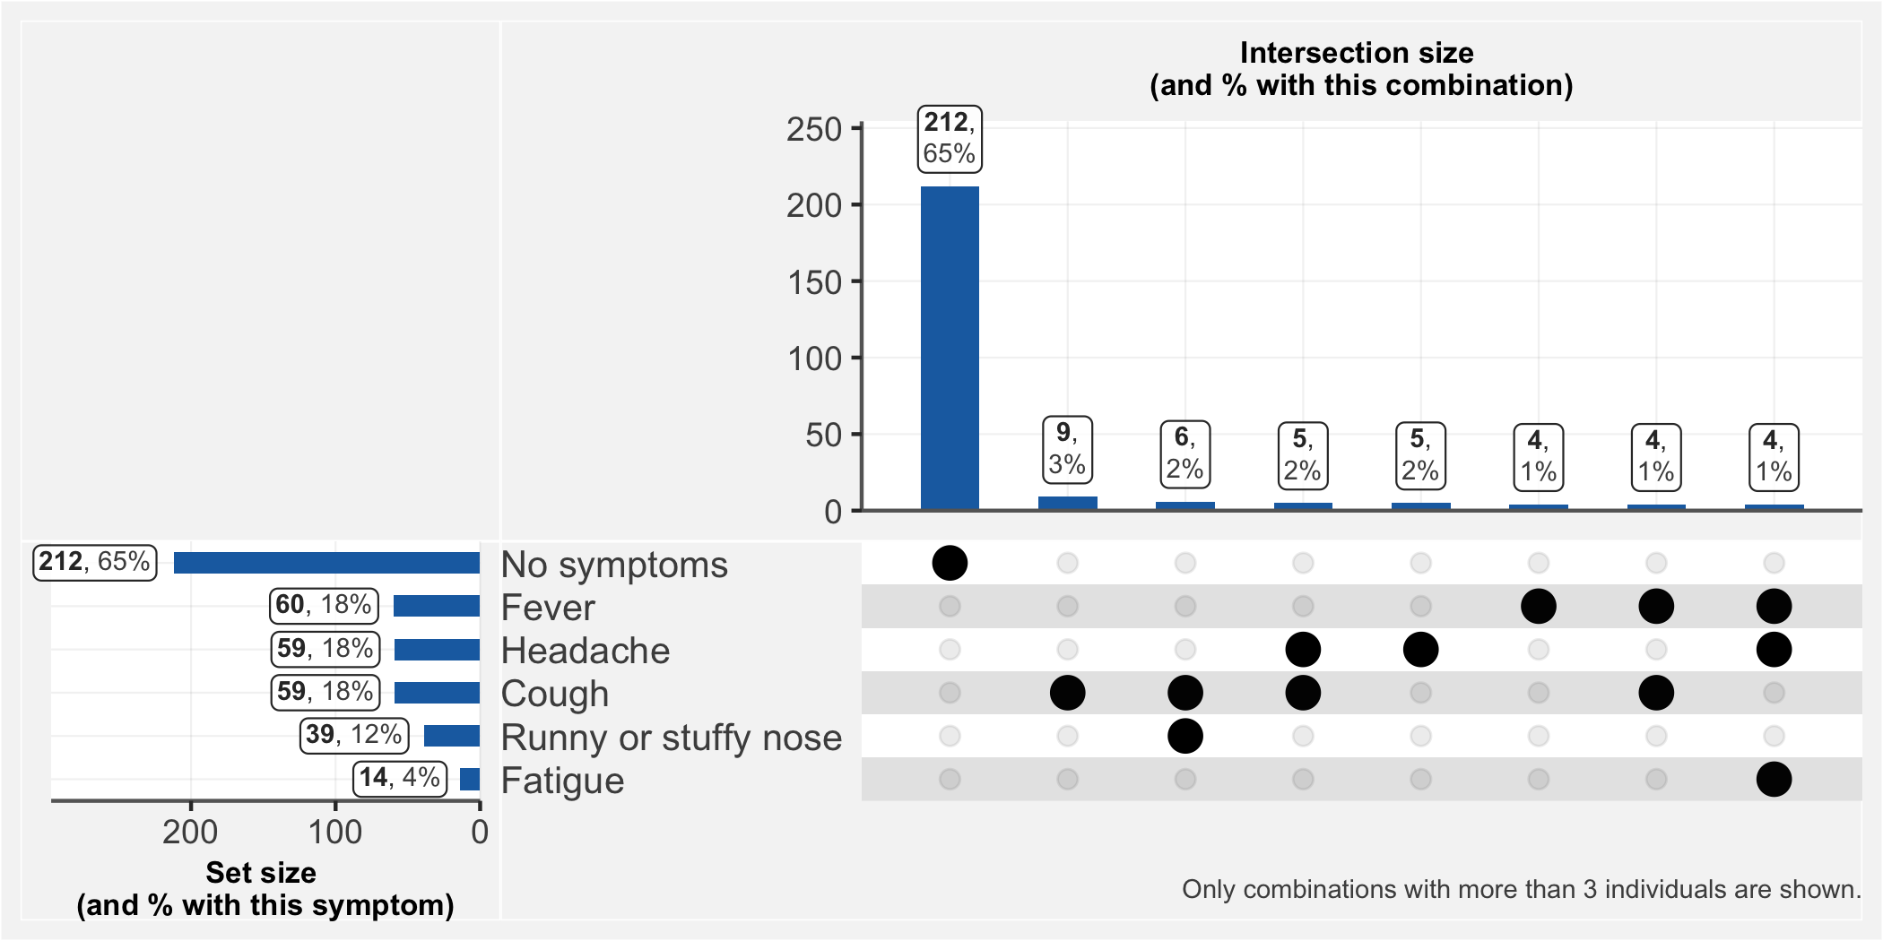

Subset of those who had negative test results for both the IgG and IgM:

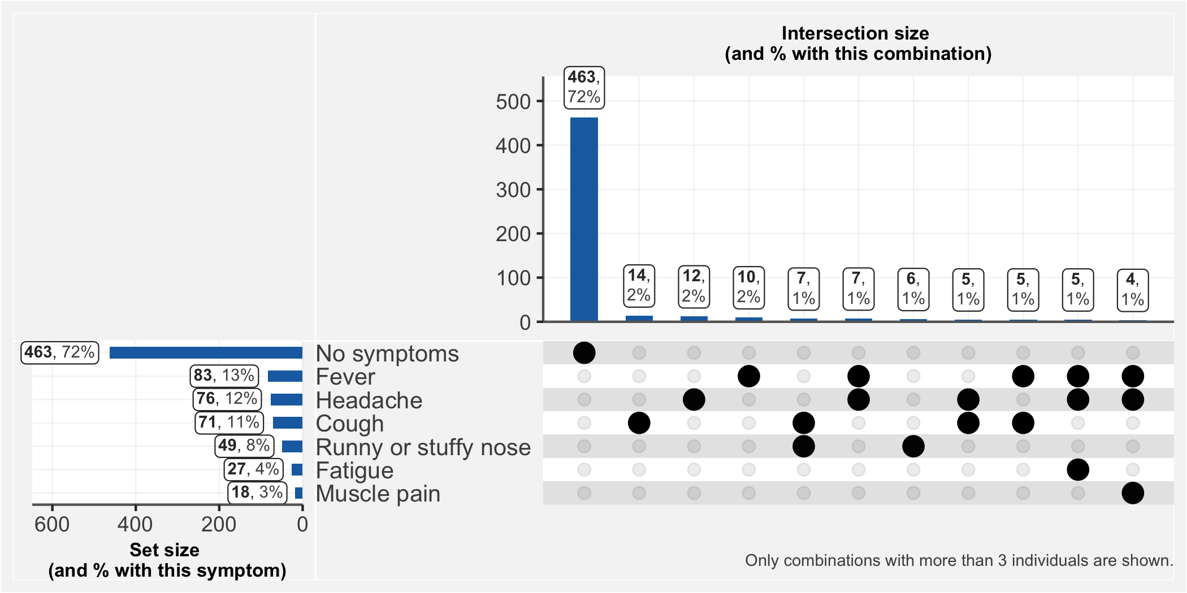

## 5.1.1 If you answered “other” to the previous question, specify

|  |  |
| --- | --- |
| **Additional Symptom** | **n** |
| constipation | 1 |
| Eruption cutanée | 1 |
| mal de ventre | 1 |
| mal de dos | 1 |

## 5.1.2 How severe have your symptoms been?

(Among those with symptoms)

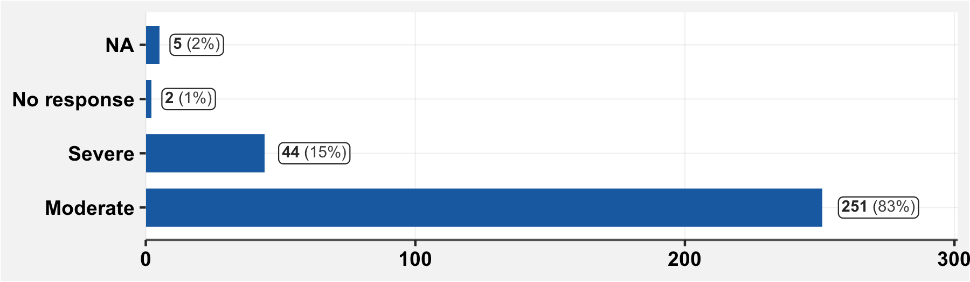

## 5.1.3 FOr how many days were you bedridden?

(Among those with symptoms)

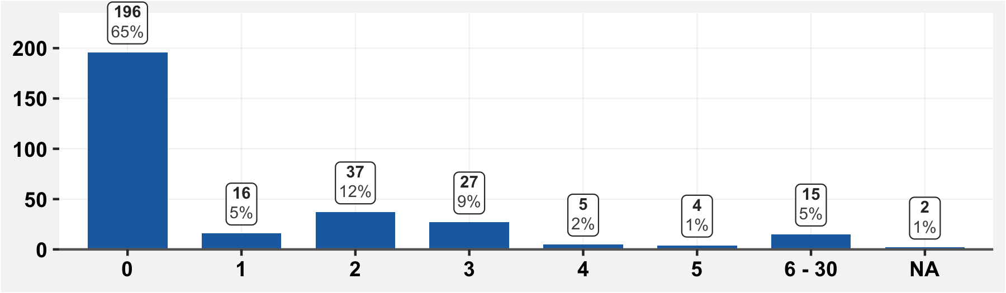

## 5.1.3 For how many days were you unable to go to work?

(Among those with symptoms)

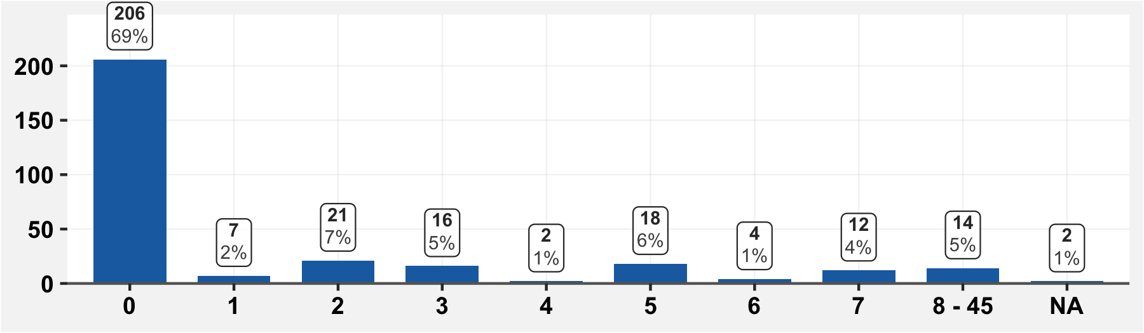

# 6 Treatment course for symptoms characteristic of COVID-19

## 6.1 Since March 1st, have you sought medical care for symptoms characteristic of COVID-19?

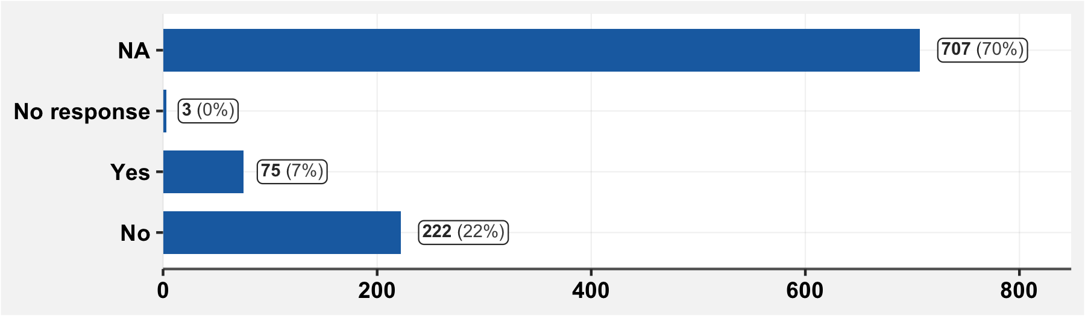

## 6.1.1 Who/Where did you consult for your symptoms?

(Among those who have consulted care.)

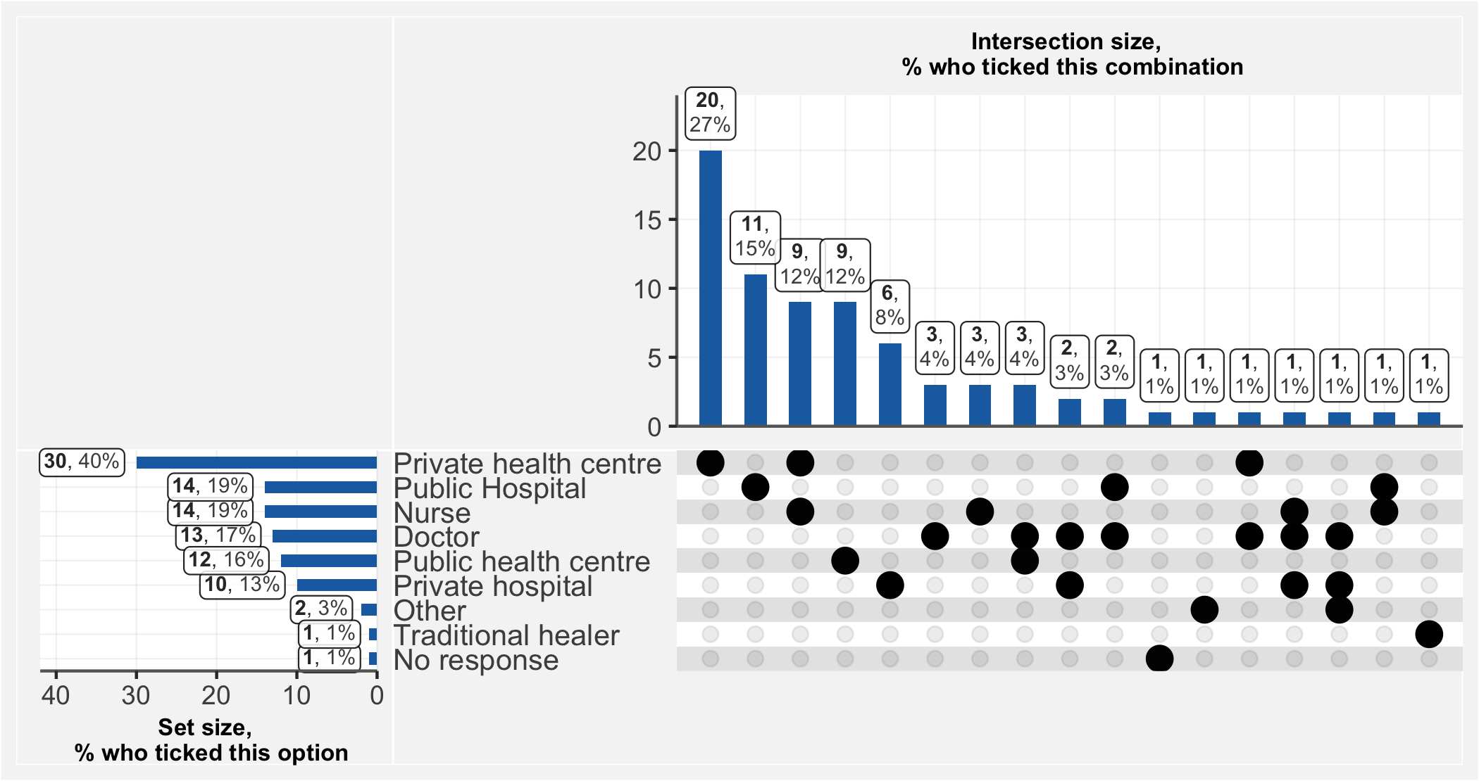

## 6.1.1.1 If you answered Other to the previous question, specify

|  |  |
| --- | --- |
| **Place of consultation** | **n** |
| Kinésithérapeute | 1 |
| Pharmacie | 1 |

## 6.2 Have you taken one or several medications for symptoms characteristic of COVID-19?

(Among those who had symptoms)

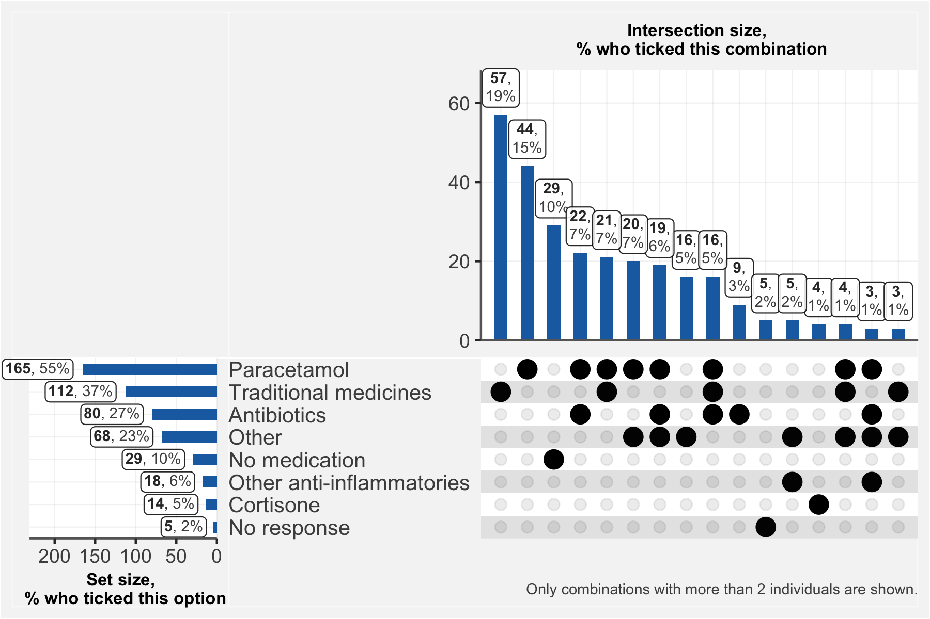

### 6.2.1 If you answered “Other” to the previous question, specify

|  |  |  |  |
| --- | --- | --- | --- |
| **Drug** | **n** | **Drug** | **n** |
| Anti Paludeen | 19 | Cefixime | 1 |
| Mixagrip | 5 | Cold Cap | 1 |
| Antipaludique | 4 | Combiart | 1 |
| Anti Paludique | 3 | Correctol | 1 |
| Anti Paludisme | 3 | Décongestionnant Nasal | 1 |
| Litacold | 3 | Dexa | 1 |
| Oublie | 3 | Duo Cotexin | 1 |
| Anti Paludein | 2 | Exomuc | 1 |
| Arthemether | 2 | Glucose | 1 |
| Vermifuge | 2 | Hpv | 1 |
| Allergenes | 1 | Lunettes Médicales | 1 |
| Analgin | 1 | Lutacold | 1 |
| Andipaludeen | 1 | Malacur | 1 |
| Anti Grippal | 1 | Migretil | 1 |
| Antitussifs | 1 | Perfusion ... Ne Connais Pas Le Traitement | 1 |
| Artefan Comprimé | 1 | Peridys | 1 |
| Artesunate Injectable | 1 | Primant | 1 |
| Arthemeter | 1 | Quinine Paracétamol Lutacold Amoxixilline | 1 |
| Arthemeter Comprimé | 1 | Sterimar | 1 |
| Bactoxin | 1 | Ventoline. Aspirine. Mucoxine. Amlibon 30. Omeprazole. | 1 |
| Bonbons Tom_tom | 1 | Vit C | 1 |

## 6.4 Have you been hospitalized since March 1st?

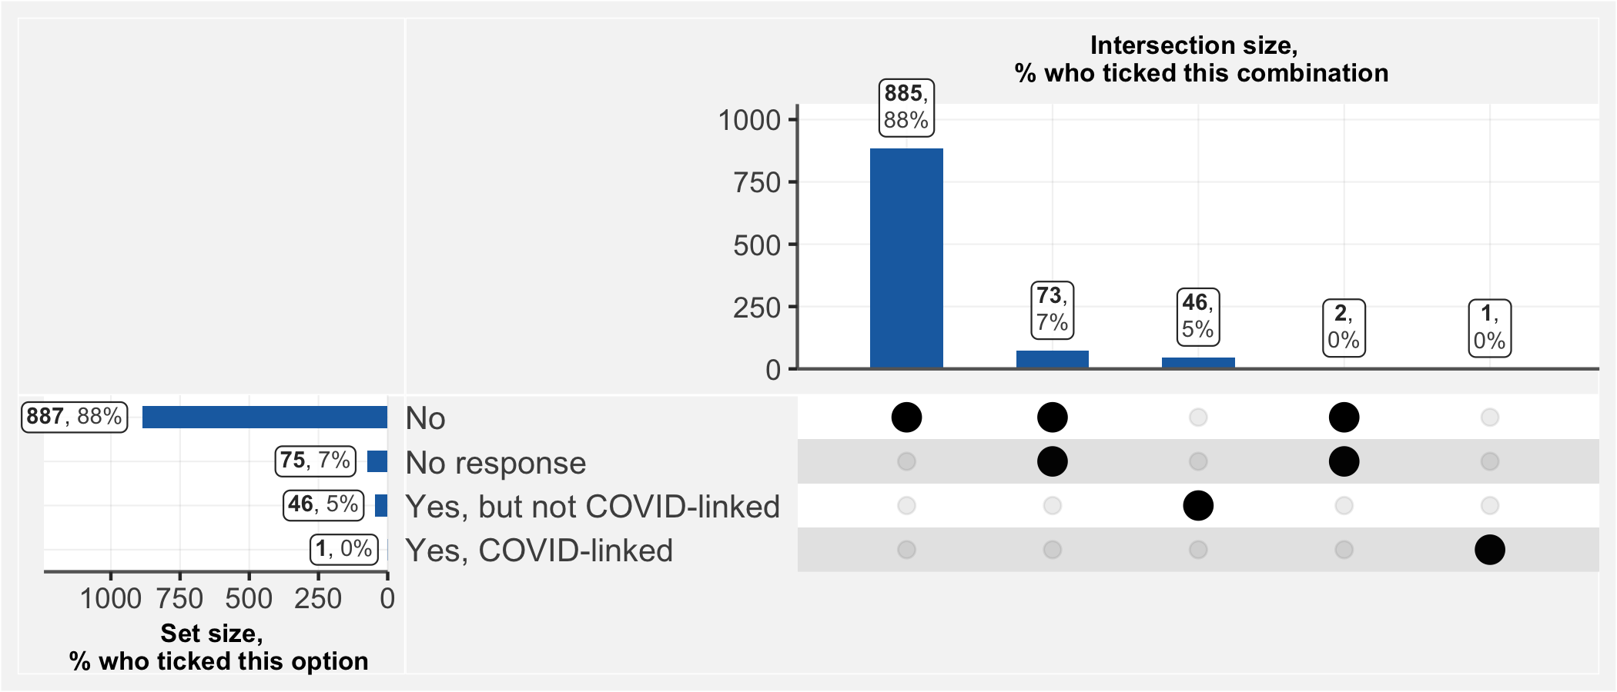

## 6.5 If you have taken steps to access care regarding suspected or confirmed COVID-19, did you pay?

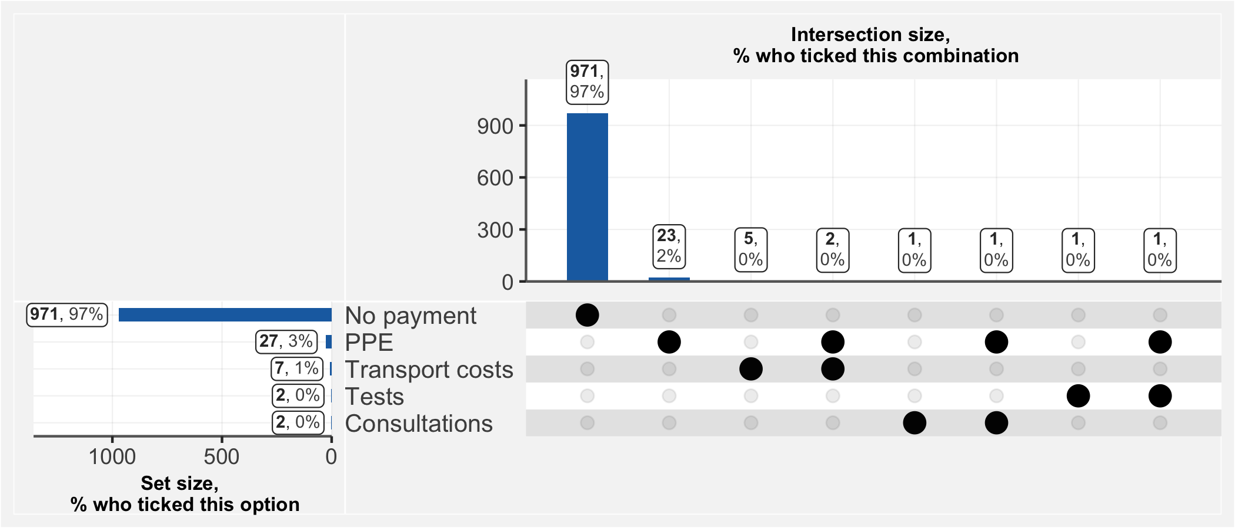

## 6.6 Have you participated in a prior COVID 19 Study?

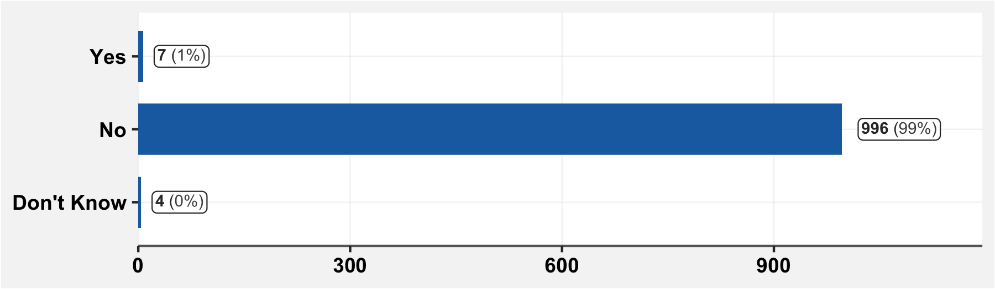

# 7 Sequelae following COVID-19-like symptoms

## 7.1 Have you had health problems which have persisted after having COVID-like symptoms?

(Subsetted to those who showed COVID-like symptoms)

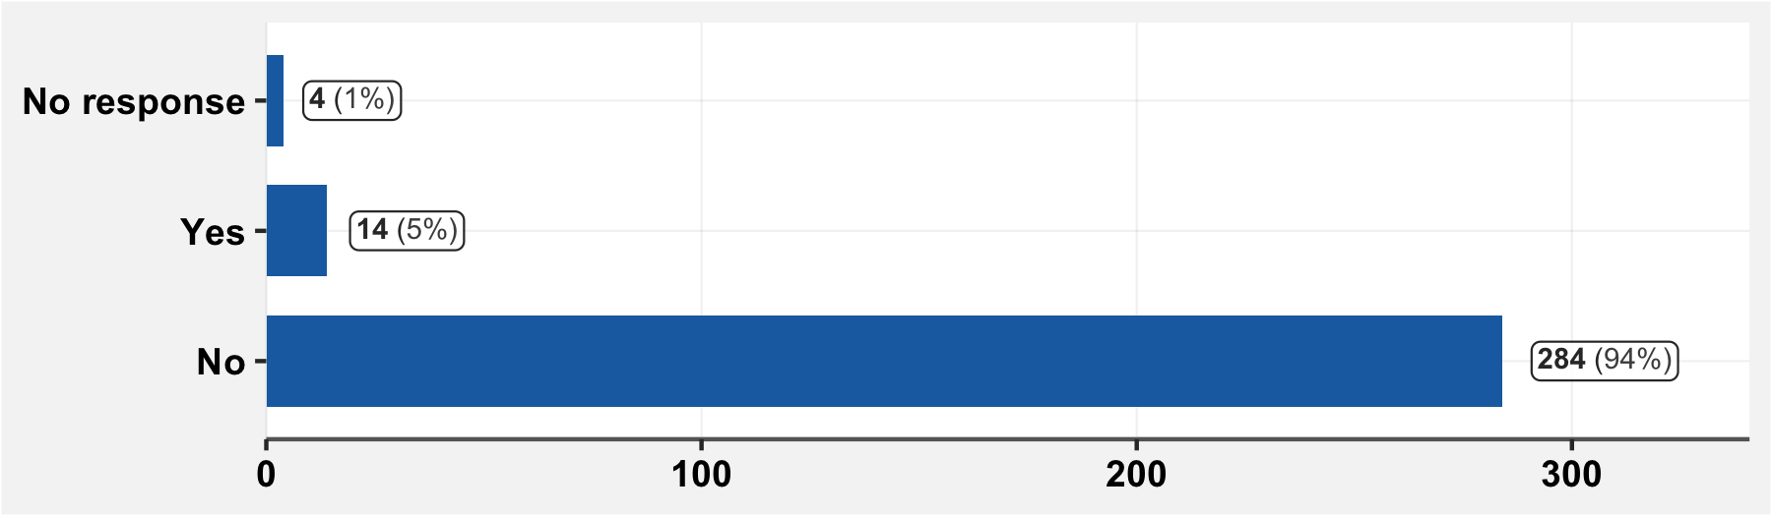

## 7.1.1 If yes to the prior question, specify

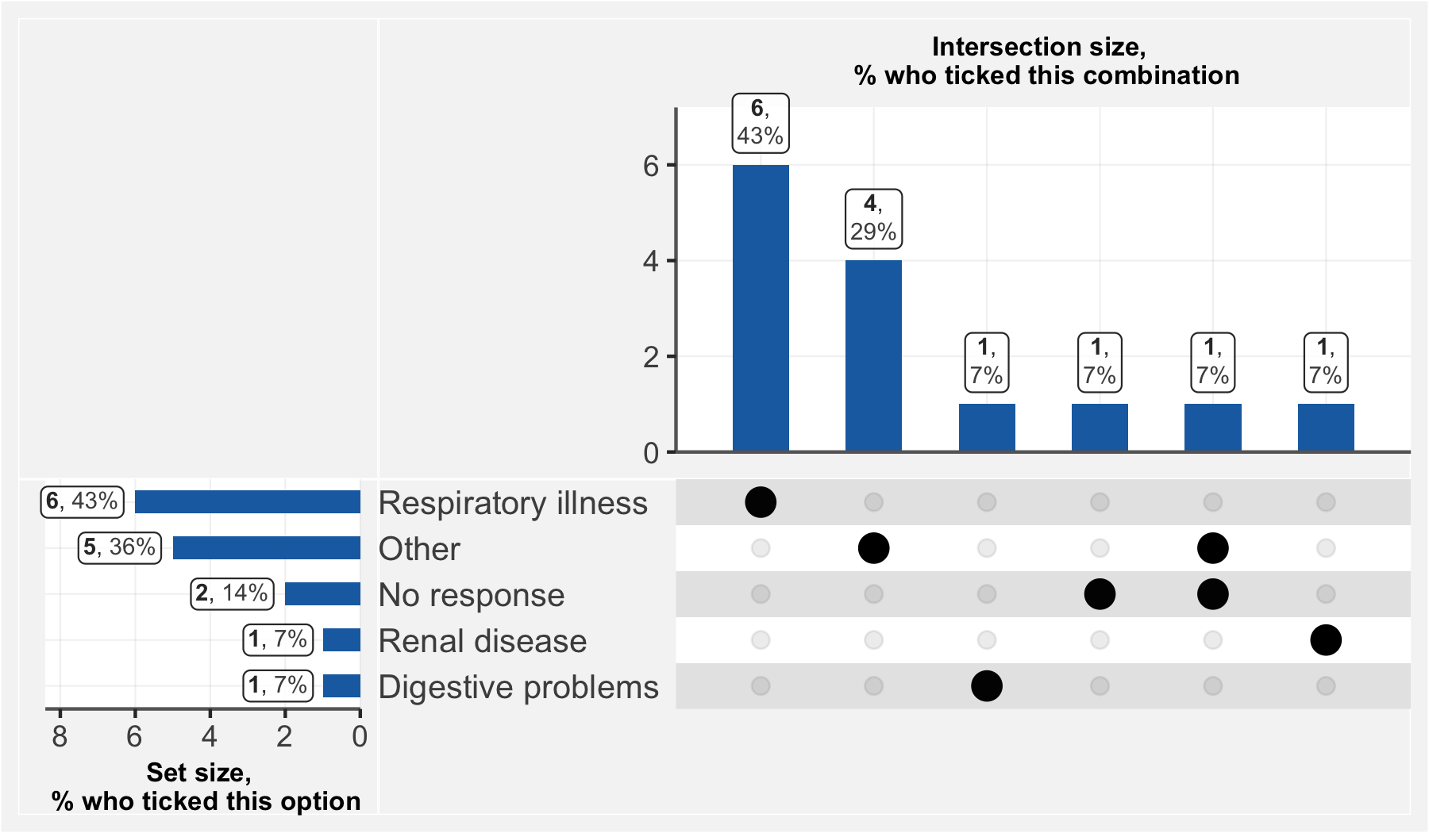

# 8 COVID-19 tests carried out before the visit

## 8.1 Have you carried out any screening test for COVID-19?

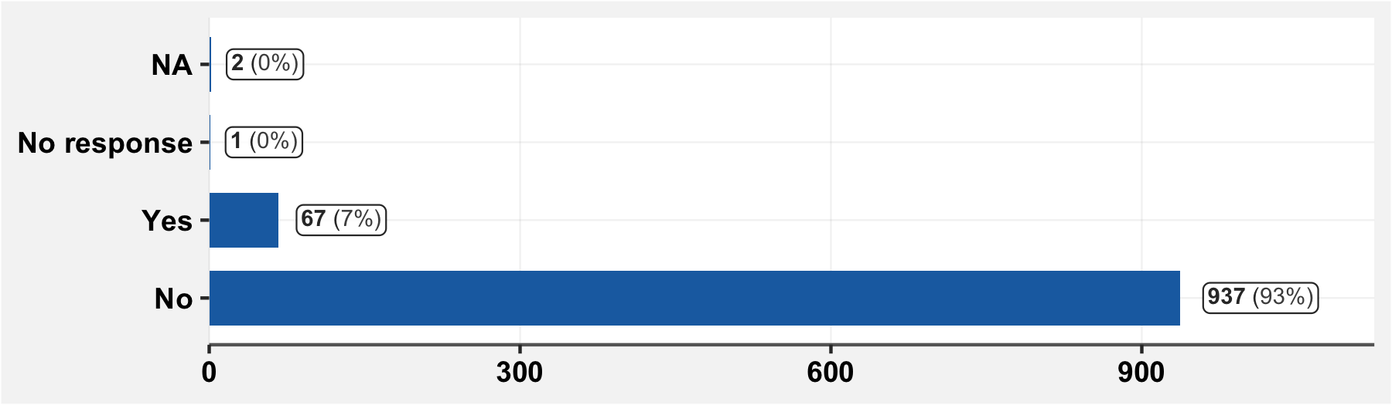

## 8.1.2 If you have previously had a COVID test, for what reason was the test done?

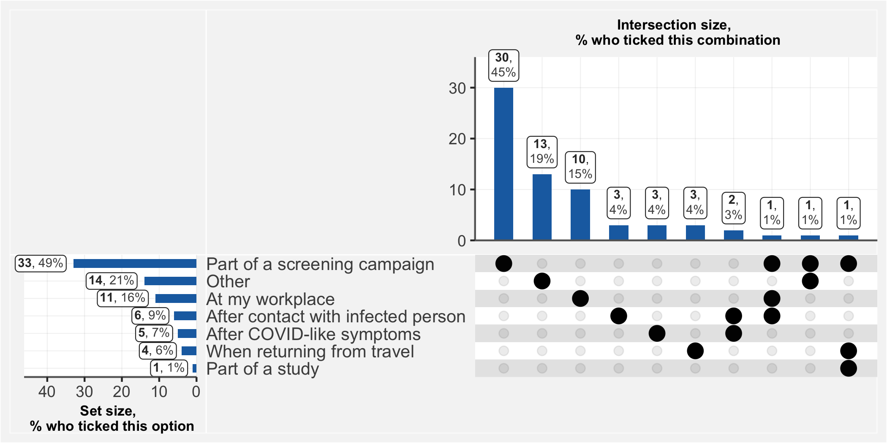

## 8.1.1.1 If you responded “Other” to the previous question, specify

|  |  |
| --- | --- |
| **Reasons for testing** | **n** |
| volontaire | 2 |
| Dans le cadre de suspicion d’un membre de la famille | 1 |
| Dossier de voyage | 1 |
| Exigé par l'administration à l'école | 1 |
| Hasard | 1 |
| Inscription à l'université | 1 |
| pour avoir accès à un service public | 1 |
| Pour un travail | 1 |
| Pour un voyage | 1 |
| rentrée scolaire des enfants | 1 |
| Test volontaire | 1 |
| Tests volontaires | 1 |
| Voyage | 1 |

# 9 Comorbidities, risk factors

## 9.1 What is your height (in cm)?

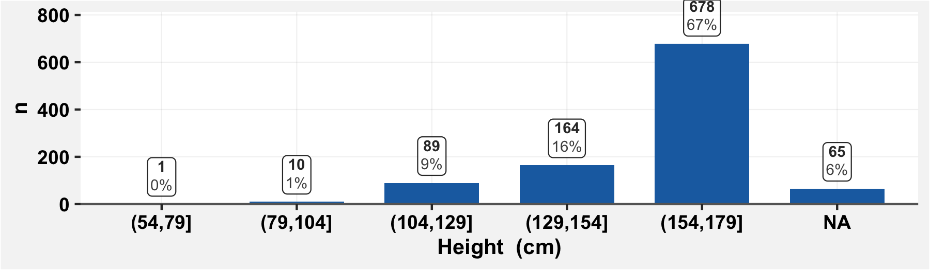

## 9.2 What is your weight (in kg)?

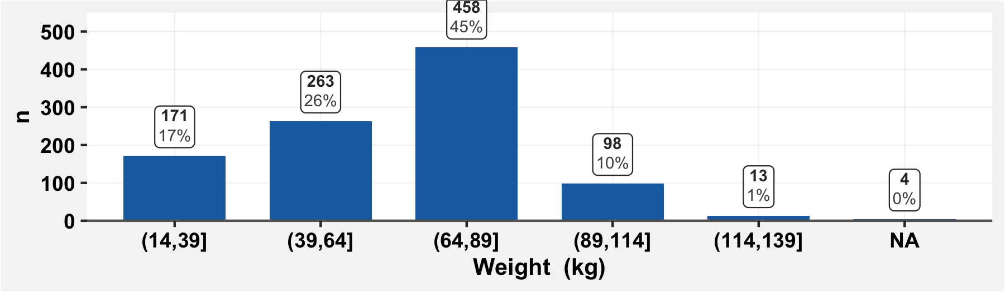

## 9.3 Are you currently a smoker?

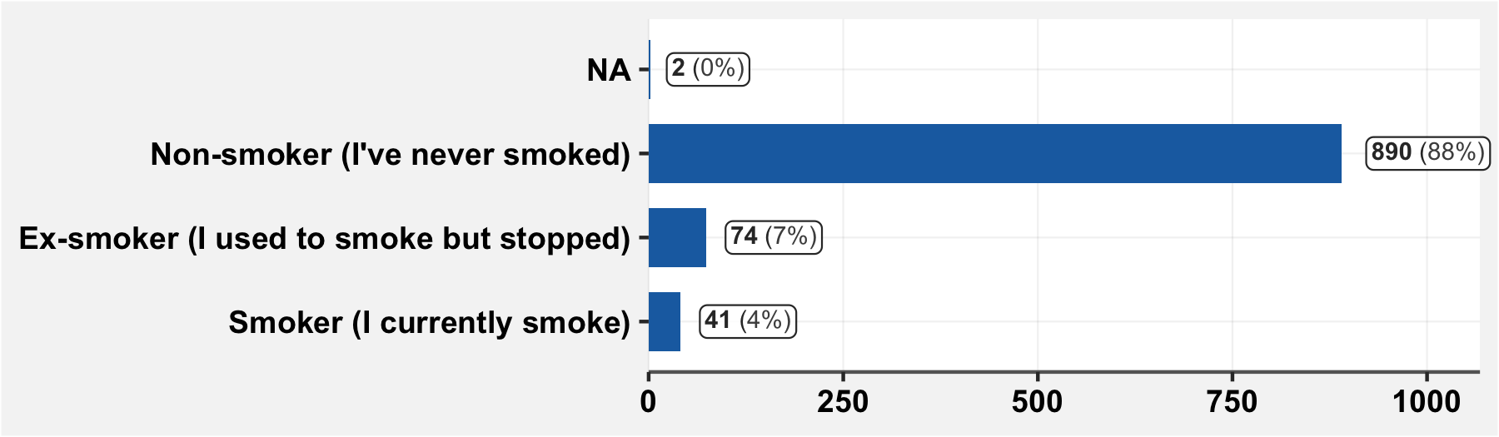

## 9.4 Do you suffer from any chronic health problems?

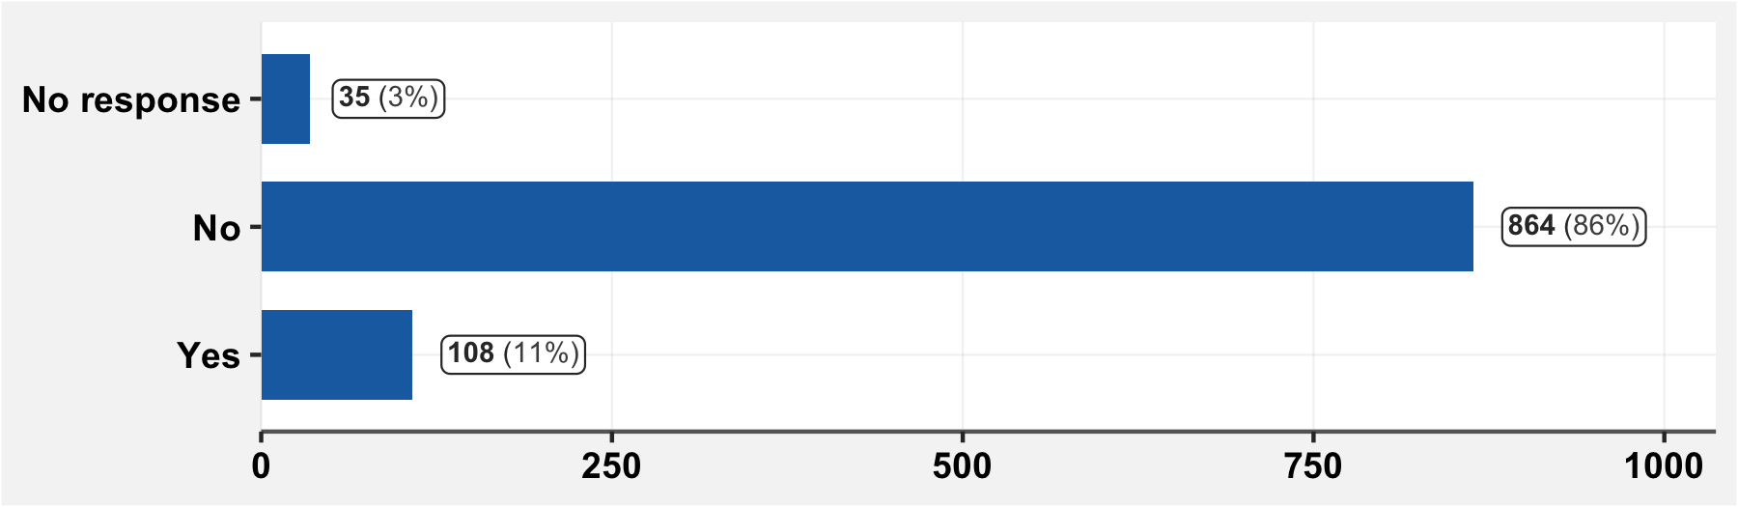

## 9.4.1 If you suffer from any health issues / chronic diseases, specify

(Only those who indicated health issues are shown. Thus, the denominator of the percentages is those with indicated issues.)

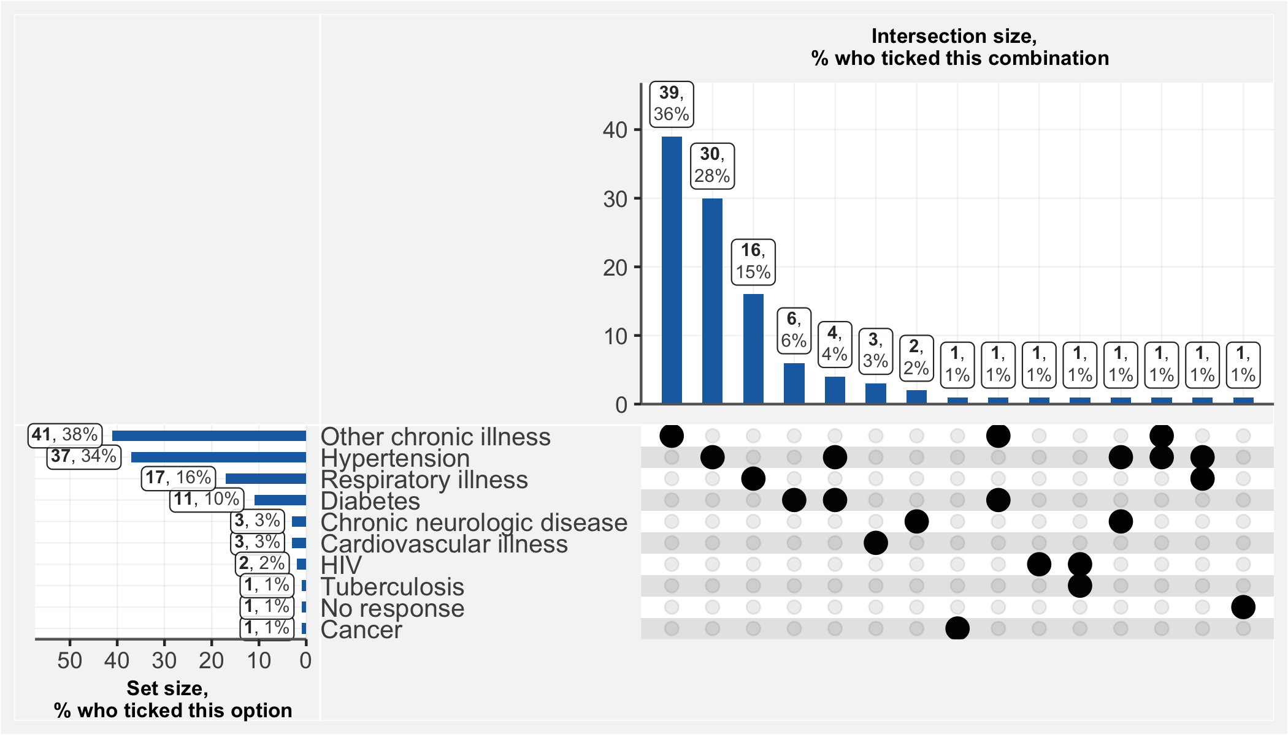

## 9.4.1.1 If you have answered “Other” to the previous question, specify

|  |  |
| --- | --- |
| **cat_chronic_other** | **n** |
| Gastrite | 5 |
| Mal De Dos | 3 |
| Mal De Nerfs | 3 |
| Mal Gastrique | 2 |
| Rhumatisme | 2 |
| Anemie | 1 |
| Arthrose | 1 |
| Arthrose Du Dos Et Du Genou | 1 |
| Asthme | 1 |
| Astigmatie | 1 |
| Athrose | 1 |
| Bronchite | 1 |
| Cataracte | 1 |
| Crampes | 1 |
| Deficit En G6pd | 1 |
| Douleurs Pelviennes | 1 |
| Fievre Jaune | 1 |
| Hemophilie | 1 |
| Hemorroides | 1 |
| Mal Aux Genoux | 1 |
| Mal D Estomac | 1 |
| Mal D'yeux Et Migraine Intense | 1 |
| Mal De Dents | 1 |
| Mal De Nerf | 1 |
| Mal De Ventre Constant | 1 |
| Mal Voyant | 1 |
| Maux De Ventre (Amibes) | 1 |
| Membres Inferieurs Douloureux Sans Diagnostic Connu. | 1 |
| Migraines | 1 |
| Myopie | 1 |
| Occulaire | 1 |
| Palpitations | 1 |
| Peau Qui Demange Avec Prurit | 1 |
| Sinusite | 1 |
| Ulcere Gastrique | 1 |
| Vision Flou | 1 |

## 9.5 Are you pregnant?

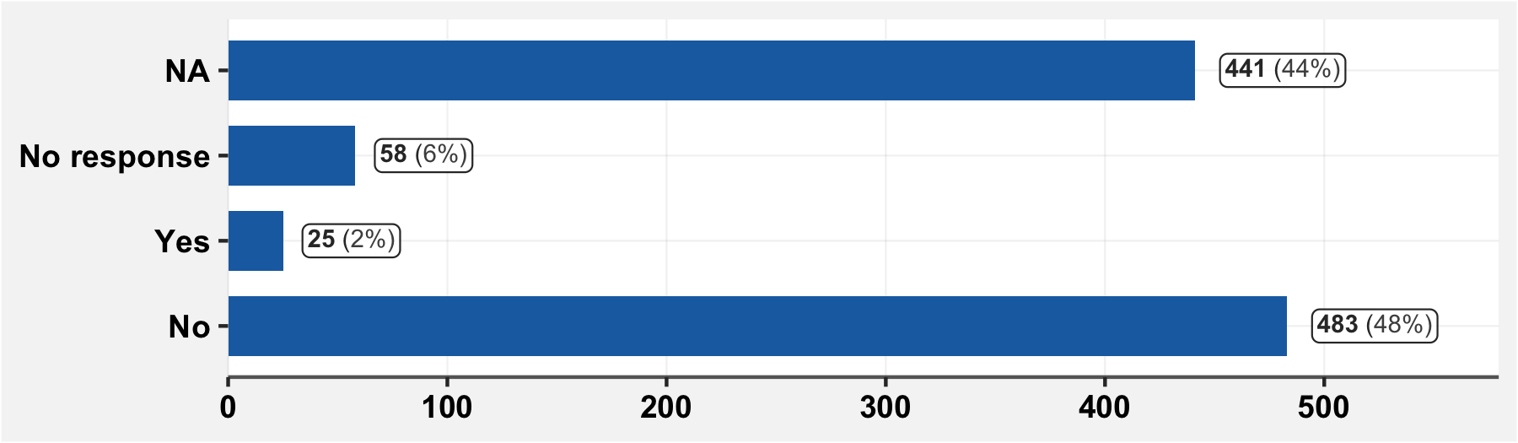

## 9.6 Do you take medications regularly?

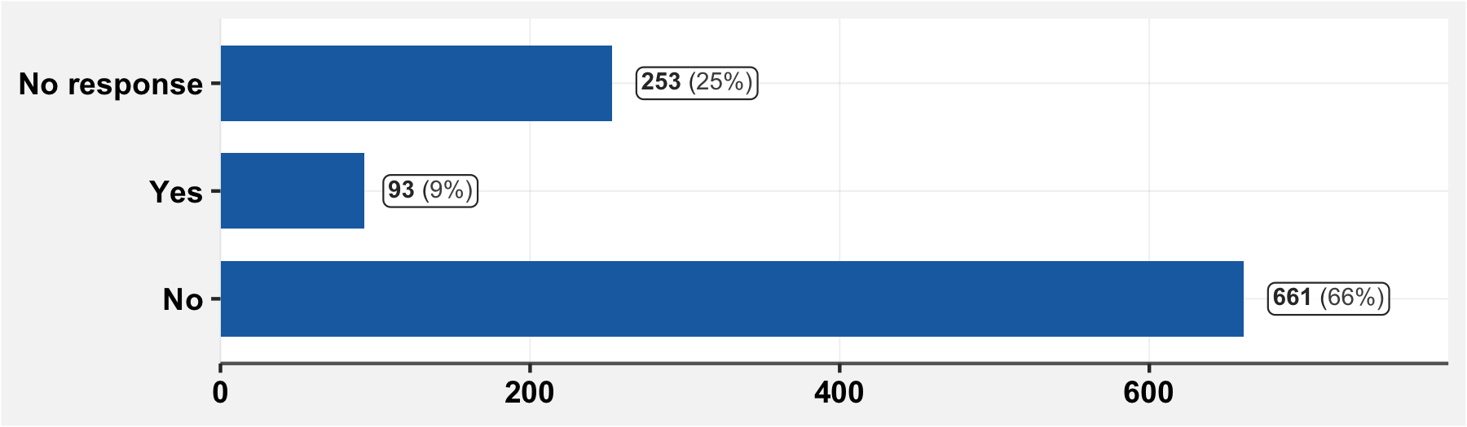

## 9.8 Have you been in contact with someone who had confirmed or suspected COVID?

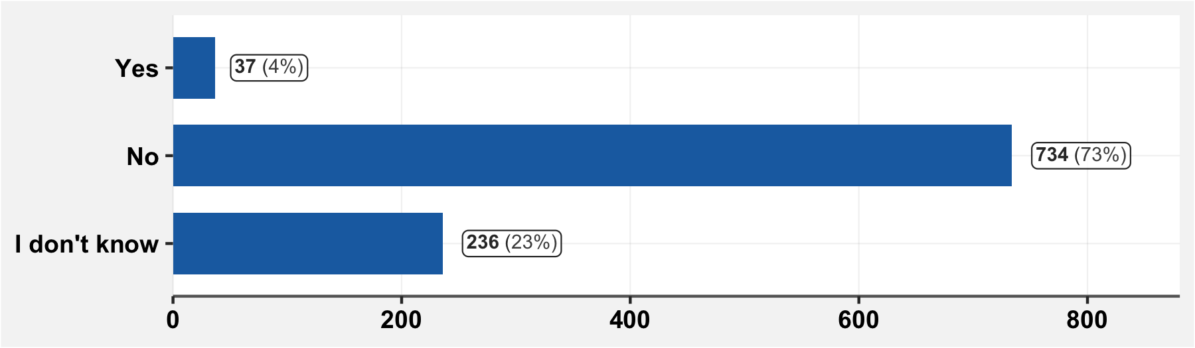

## 9.9 Have you been in contact with someone coming from abroad?

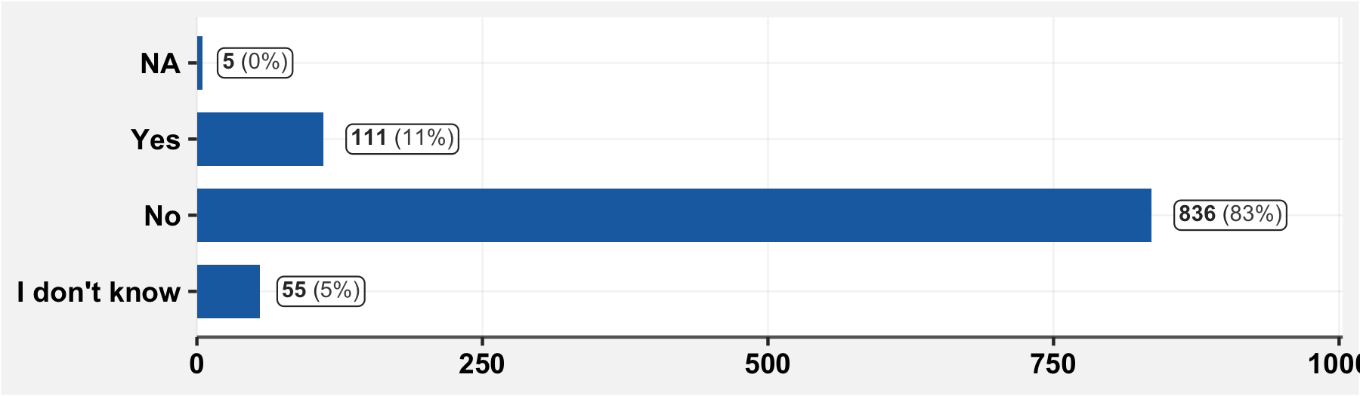

## 9.10 Do you think that your risk of getting infected with the new virus is…?

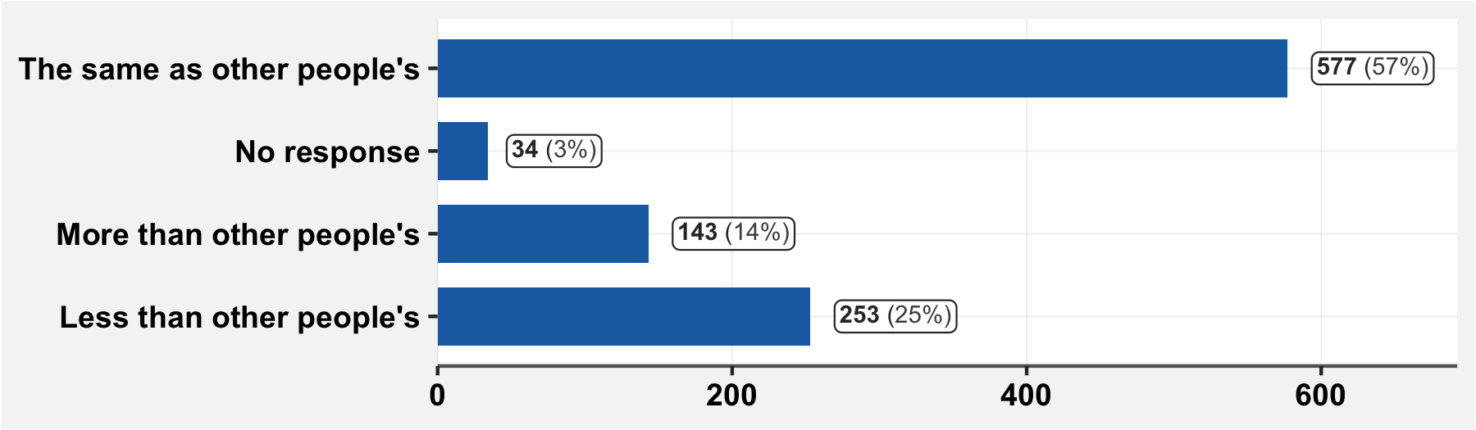

# 10 Difficulty of access to care

## 10.1 Since March 1st, have you had difficulty in obtaining medical care?

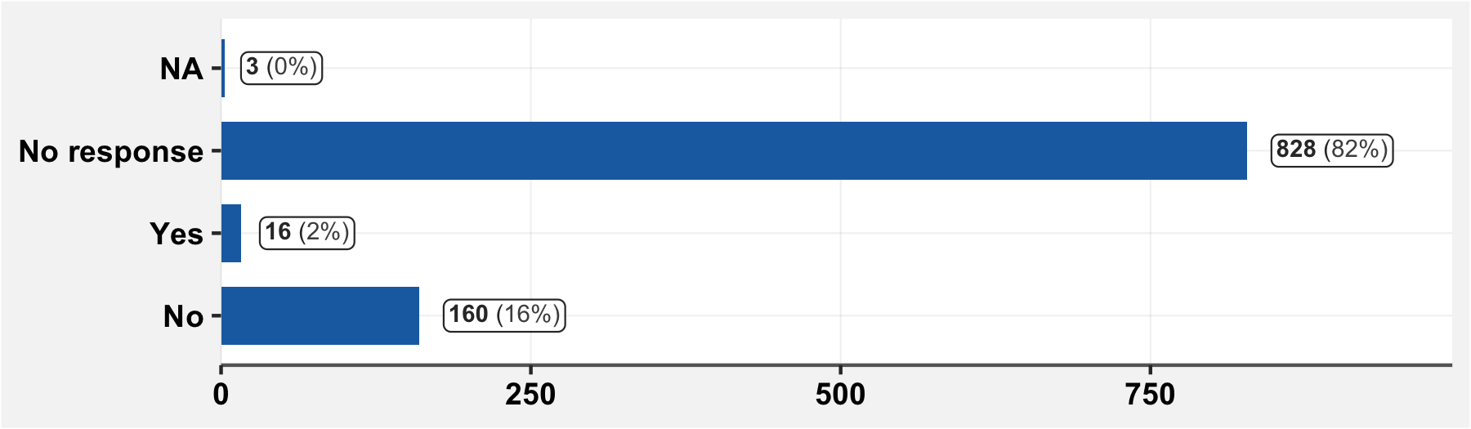

And, only among those who reported symptoms since March 1st or have a chronic condition:

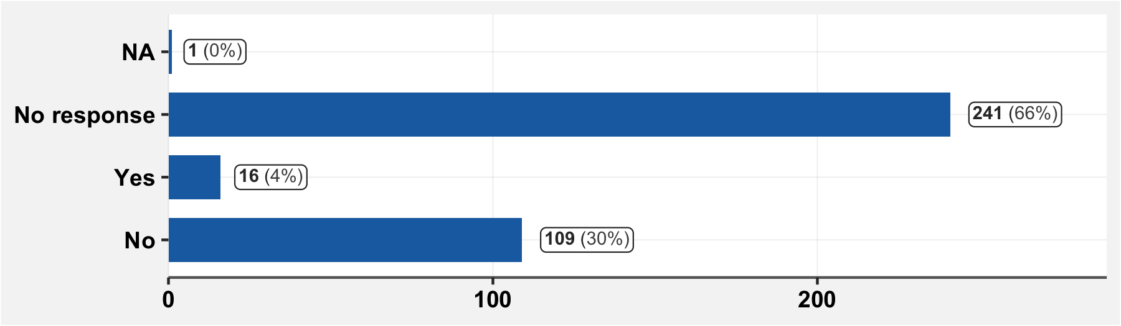

## 10.1.1 If you had difficulty in obtaining medical care, specify

|  |  |
| --- | --- |
| **Difficulty** | **n** |
| Asperites,Melemt 1000 | 1 |
| Collyres | 1 |
| Consultation | 1 |
| Consultation Chez Le Gastro | 1 |
| Consultation Et Achat De Medicaments | 1 |
| Consultation. | 1 |
| Difficultes Financieres | 1 |
| Finances | 1 |
| Financiere | 1 |
| Fuite De L'hopital Sur Fond De Rumeur | 1 |
| L'argent Pour Payer Mes Medicaments | 1 |
| Ophtalmologie,Seuls Les Urgences Etaient Accessibles | 1 |
| Prise En Charge | 1 |
| Rdv Chez Le Dentiste | 1 |
| Soins Et Controle Hta Et Diabete | 1 |
| Suivi Du Diabete | 1 |

## 10.2 Since the first of March, have you been unable to access your usual medications?

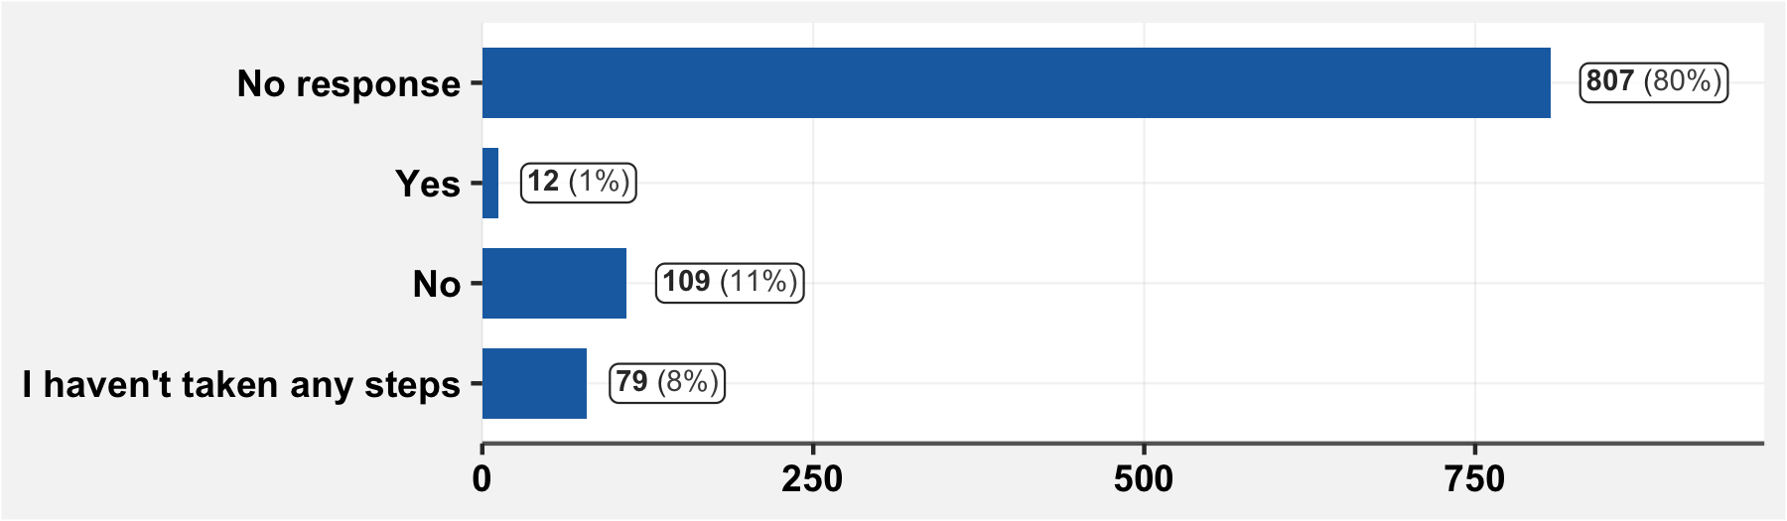

Only among those who answered “yes” to question 9.6, “do you take medications regularly?”:

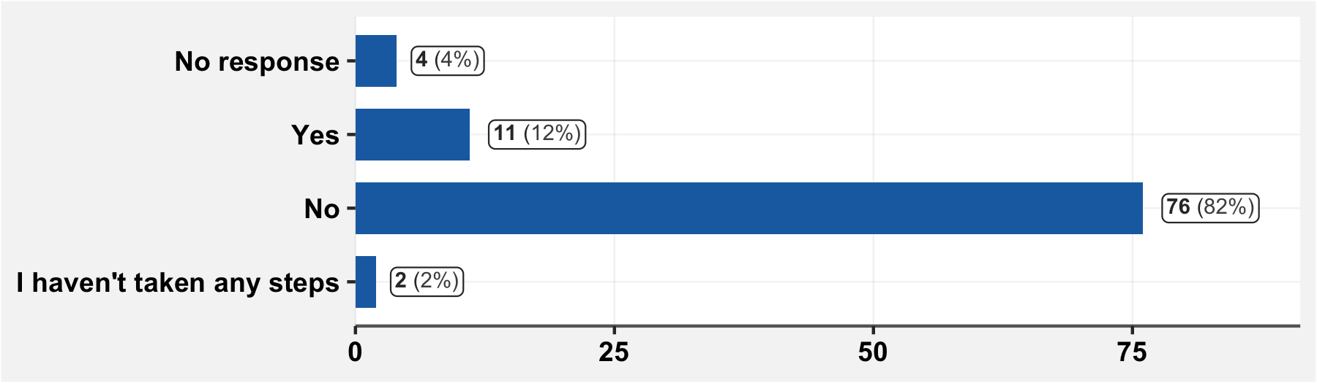

And, only among those who reported symptoms since March 1st or have a chronic condition:

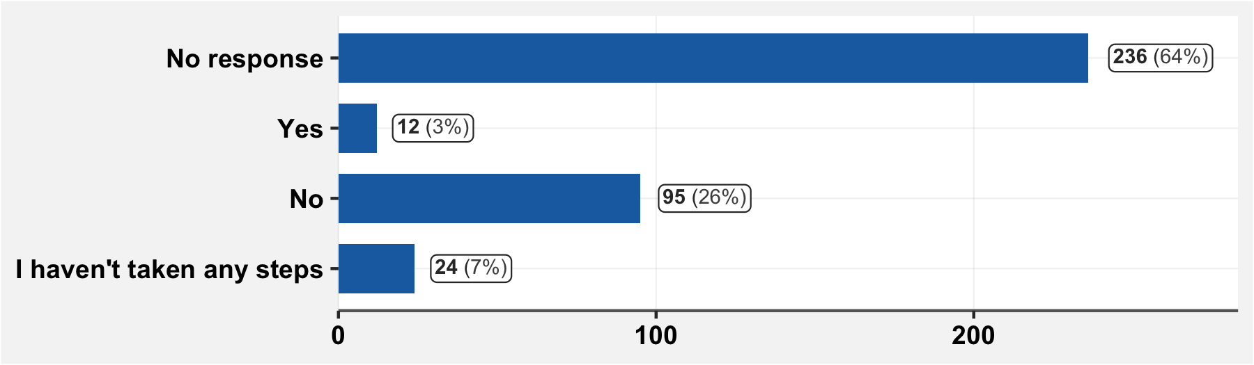

## 10.2.1 If you have been unable to access your medications, what are the medications concerned?

|  |  |
| --- | --- |
| **Medication** | **n** |
| Collyres | 1 |
| Corticoides | 1 |
| Diapride 4 | 1 |
| Escodyne,Migretil | 1 |
| Fenegan 25 | 1 |
| Fer Acide Folique | 1 |
| Glucagon | 1 |
| Konpon, Cimetidine | 1 |
| Maalox Au Niveau Du Centre De Sante | 1 |
| Metformine Hci,Hydrochlorothiazide,Aspirine Cardio,Tanganil Pro | 1 |
| Turbuhaler | 1 |
| Zoprazid | 1 |

# 11 Financial barriers to medical access

## 11.1 Do you have health insurance?

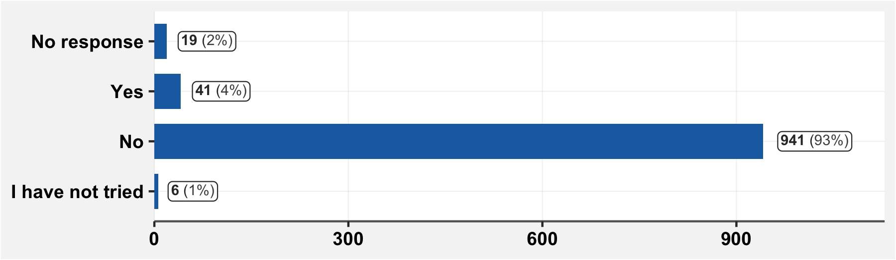

## 11.2 Since March 1st, have you had difficulty in paying your insurance primes?

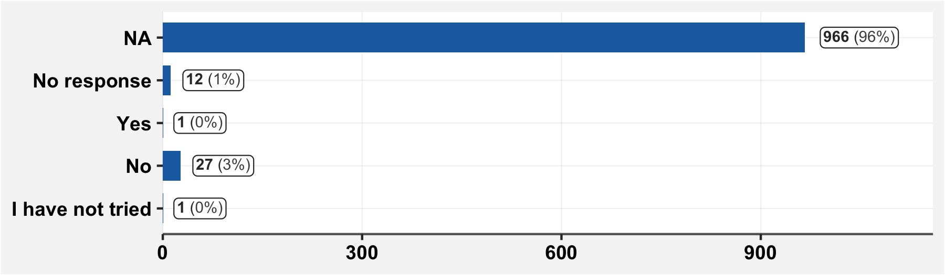

## 11.3 Since March 1st, have you encountered financial difficulty in paying for medical care or medications?

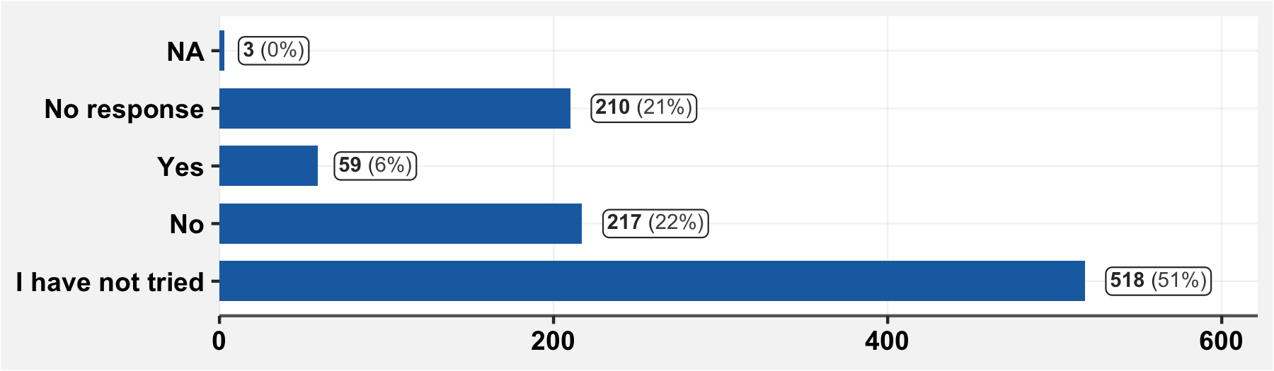

And, only among those who reported symptoms since March 1st or have a chronic condition: 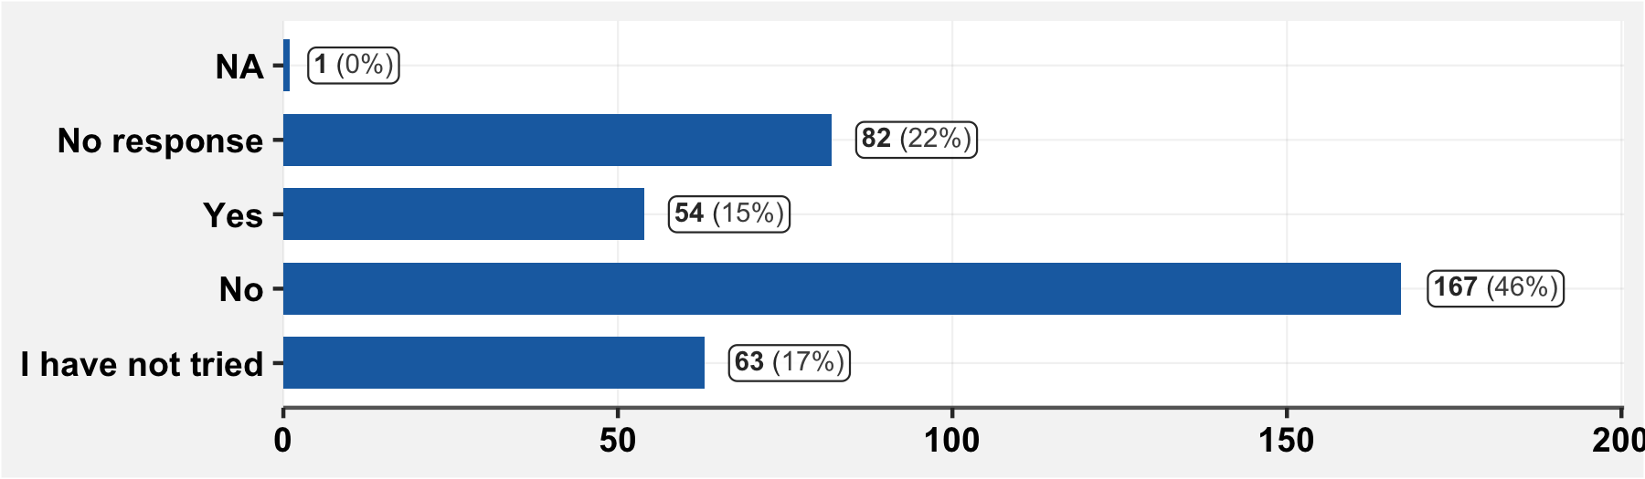

## 11.4 Since March 1st, have you experienced delays in care for financial reasons?

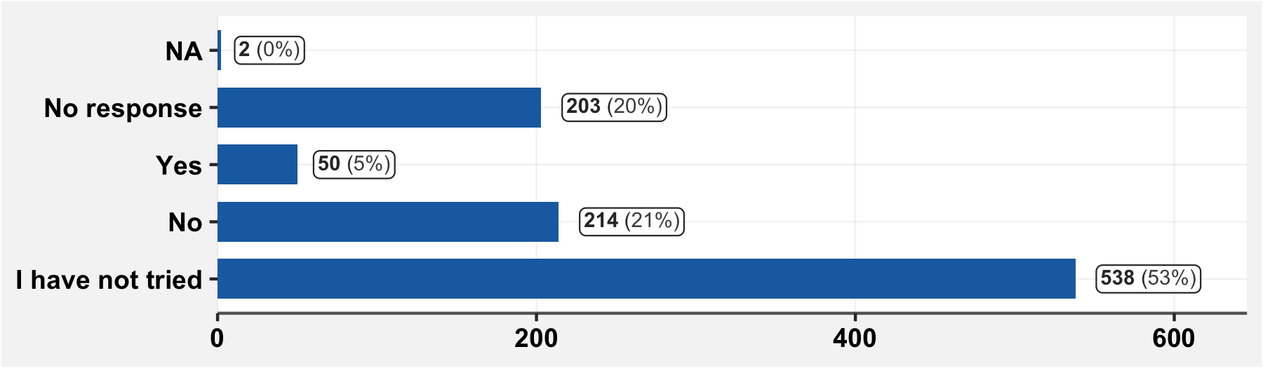

And, only among those who reported symptoms since March 1st or have a chronic condition: 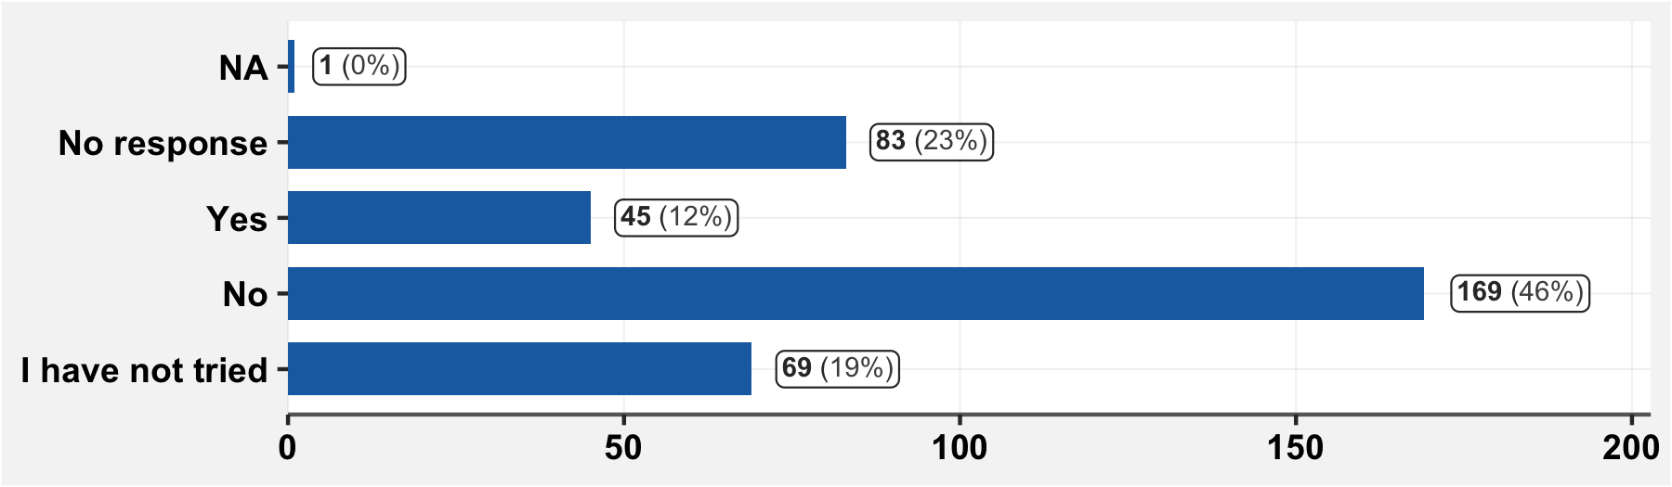

## 11.5 If you have sought out medical care due to suspicion or confirmation of COVID, did you have difficulty in paying for transport costs, care or medication?

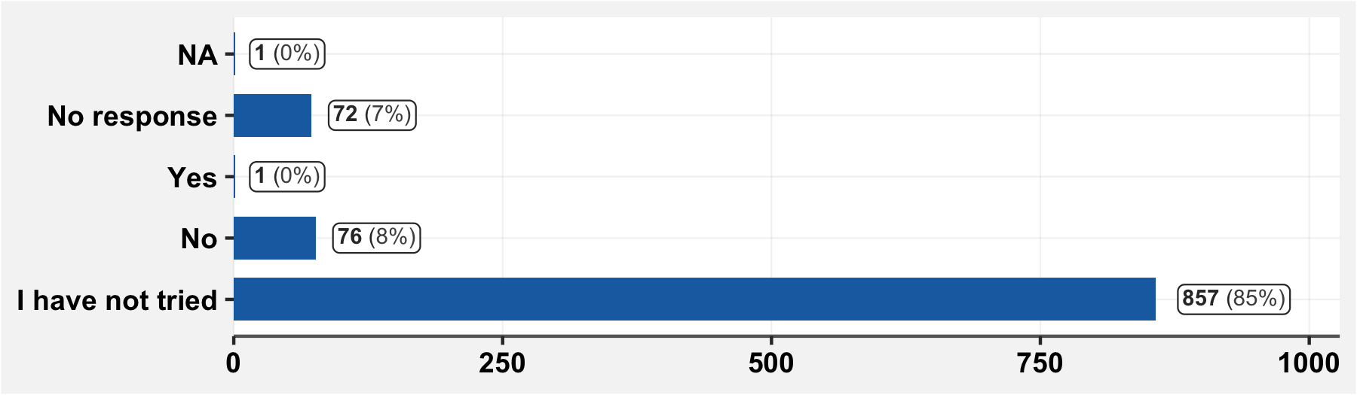

And, among those who have consulted care

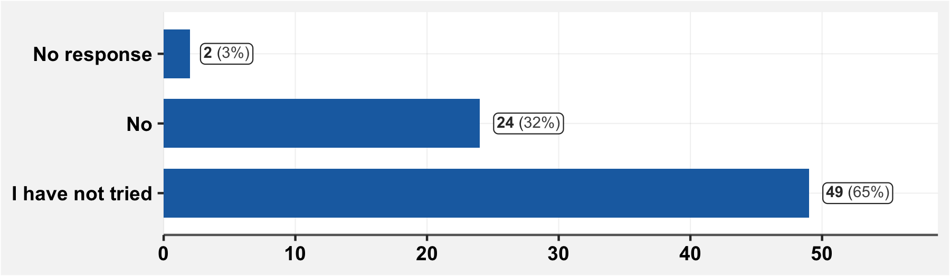

## 11.6 Since March 1st, have you consulted care for non COVID-like symptoms?

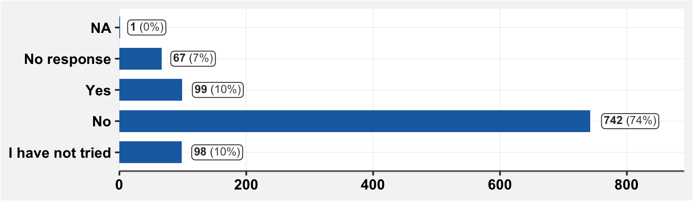

# 12 Other barriers to medical access (geography, perception)

## 12.2 Have you had difficulty in accessing medical centers due to inavailability or raised prices of transport?

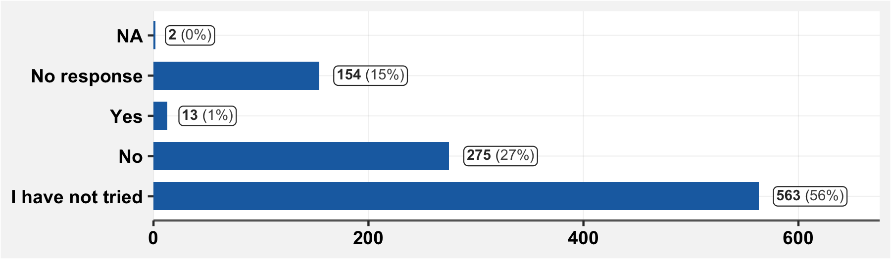

And, only among those who reported symptoms since March 1st or have a chronic condition:

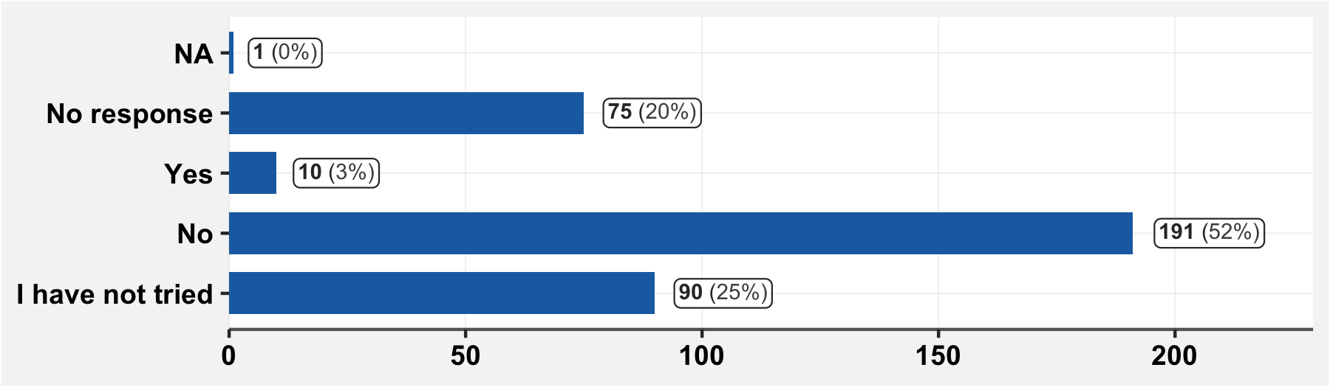

## 12.2.1 Explain your answer to the previous question

|  |  |  |  |
| --- | --- | --- | --- |
| **Item** | **n** | **Item** | **n** |
| rien n'a change | 55 | inapproprie | 1 |
| tout est normal | 21 | inappropriee | 1 |
| comme toujours | 20 | la prise en charge est relachee | 1 |
| ras | 19 | le respect des mesures barrieres y est de rigueur | 1 |
| tout va bien | 8 | le service s est ameliore dans les hopitaux | 1 |
| rien | 7 | les grands hopitaux recoivent mal les patients | 1 |
| rien a change | 5 | les grands hopitaux sont dangereux | 1 |
| rien n a change | 5 | les hopitaux continuent de recevoir comme avant | 1 |
| les mesures barrieres sont relachees | 4 | les hopitaux sont plus securises | 1 |
| normale | 4 | les hopitaux sont plus strictes | 1 |
| rien a changer | 4 | les mesures barrieres sont devenues de rigueur | 1 |
| aucune des propositions | 3 | les mesures d hygiene sont accentuees | 1 |
| je ne sais pas | 3 | les services sont lents | 1 |
| comme d habitude | 2 | les structures de sante sont ouvertes | 1 |
| les hopitaux sont vides | 2 | les structures privees prennent plus soin des patients | 1 |
| les structures privees sont plus acceuillantes | 2 | les structures sanitaires sont vides | 1 |
| ne sais pas | 2 | ne sait pas | 1 |
| rien de tout ca | 2 | nomale | 1 |
| accueil deplorable | 1 | normal | 1 |
| aucune | 1 | nrp | 1 |
| aucune difference entre aujourd'hui et avant | 1 | pas de reponse de l'enfant | 1 |
| aucune reponse | 1 | pas ete malade | 1 |
| c est accessible | 1 | plus acceuillants | 1 |
| c est pareil qu avant | 1 | que les hopitaux sont plus securises | 1 |
| comme avant | 1 | que les mesures d hygiene doivent etre plus accentuees | 1 |
| comme avant il faut juste prendre ses precautions | 1 | rien n a change,trop de racket | 1 |
| comme d'habitude | 1 | structures privees sont plus fiables | 1 |
| elle ne s y est pas interressee | 1 | toujours comme avant | 1 |
| hopital central vide, hopital des soeurs surcharge | 1 | tout est comme avant | 1 |
| il etait informe de l'existence de centres de prise en charge covid 19 | 1 | tout fonctionne normalement | 1 |

# 13 Behavior, hygiene, protective measures, physical distancing

## 13.1 Do you respect the simple rules of hygiene (sash hands frequently, sneeze into your elbow, use a disposable handkerchief, etc.)?

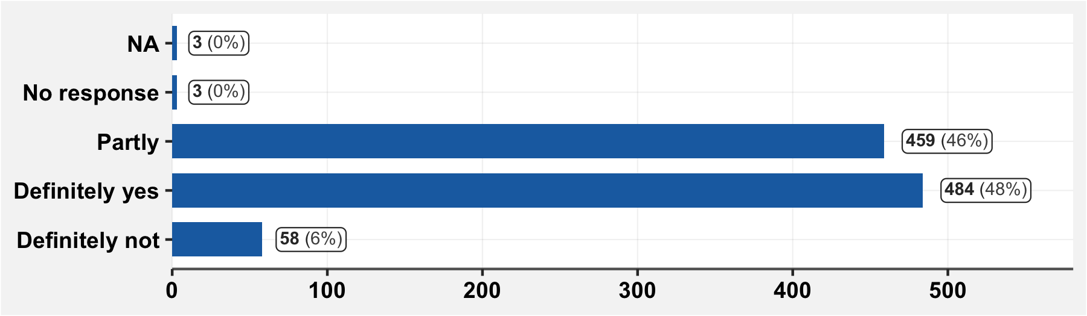

## 13.2 Do you respect the simple rules of social distancing (avoid handshakes or hugs, avoid unnecessary outings, etc.)?

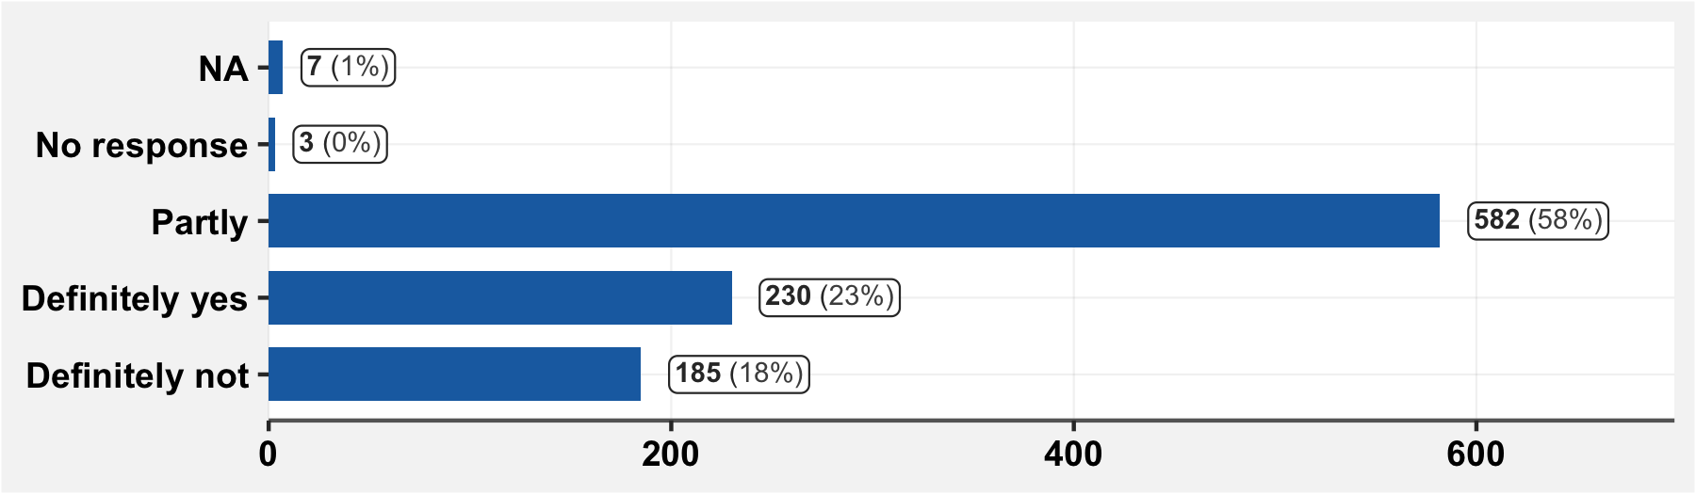

## 13.3 Since March 1st, have you remained confined?

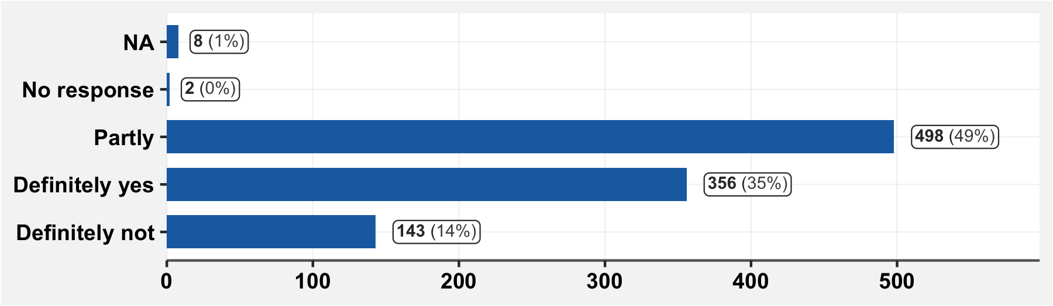

## 13.4 Since March 1st, have you been worried about contracting COVID-19?

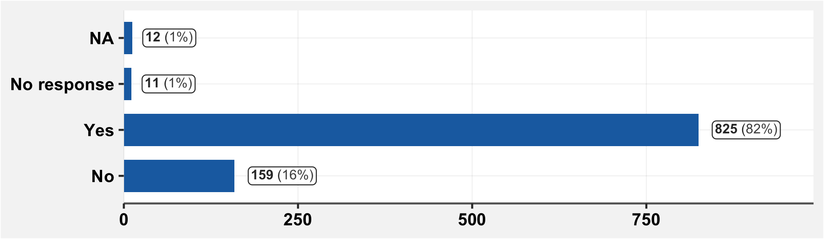

## 13.5 Since March 1st, have you been worried about the reaction of the people around you if you were to contract COVID-19?

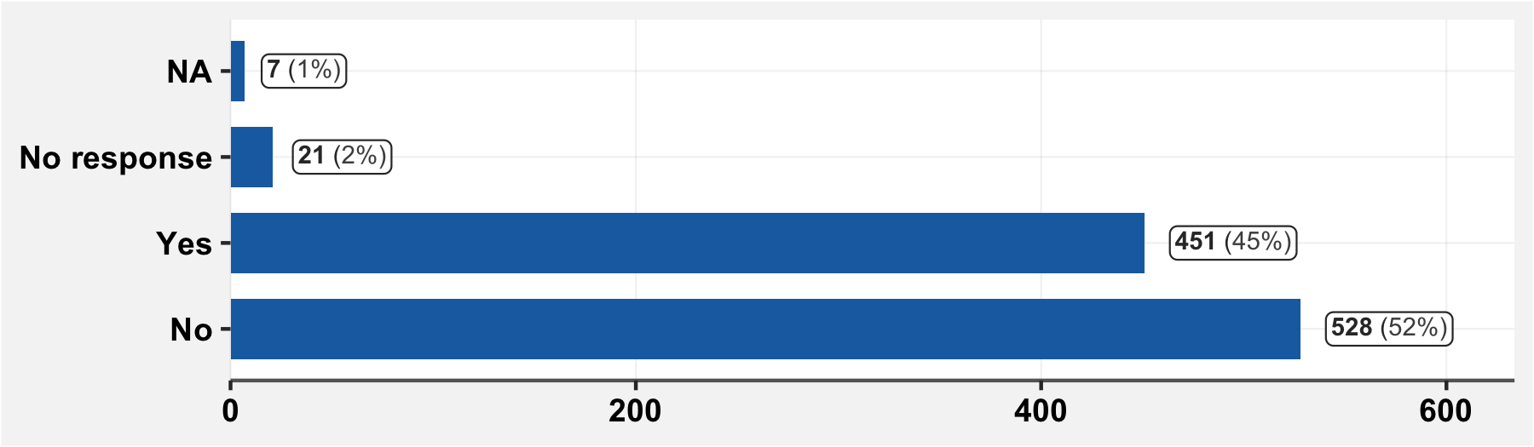

## 13.6 Do you think that people who contract COVID-19 are stigmatised and avoided by others?

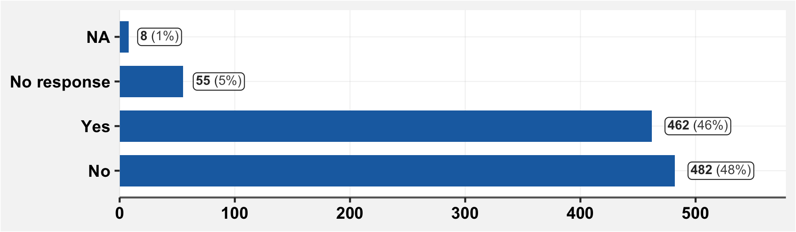

## 13.7 Would you hide your illness if you were to contract COVID-19?

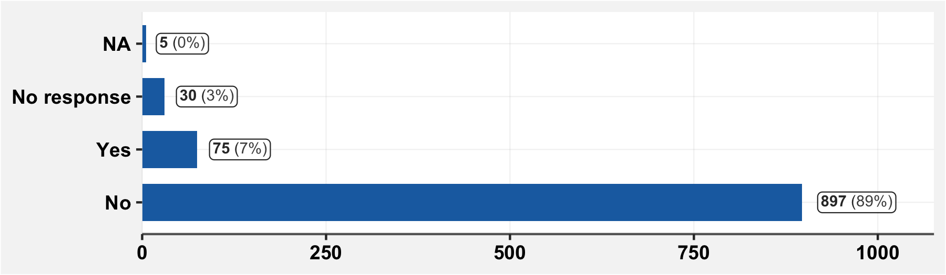

# 14 Impact of the COVID-19 confinement on you

## 14.1 Since March 1st, have you been unable to carry out your daily activities (other than work, such as visiting family, making meals, taking care of the children…) because of the confinement?

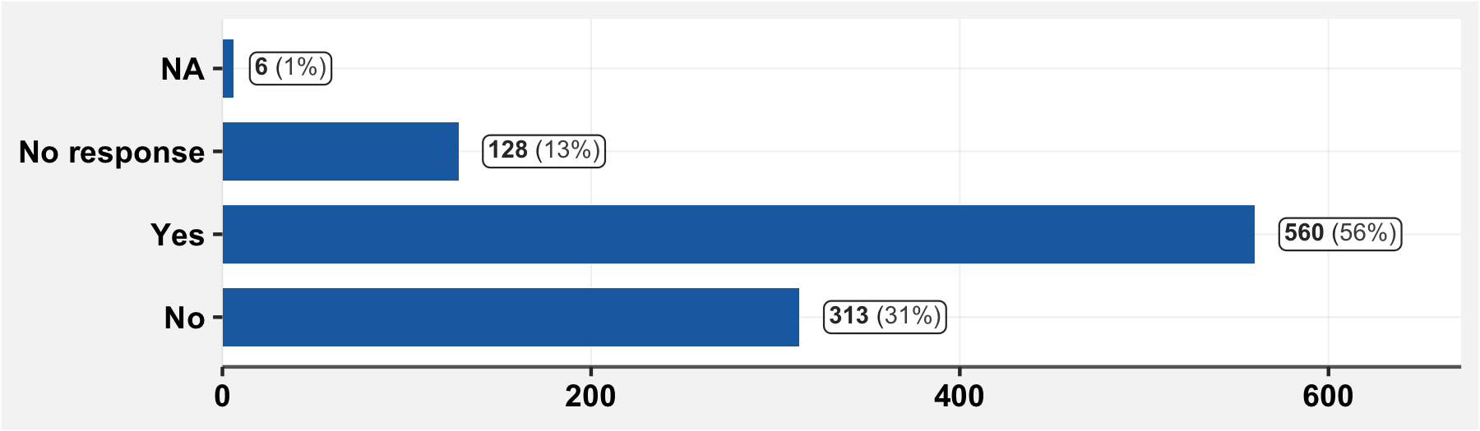

## 14.2 Since March 1st, have you stopped working or stopped one of your jobs due to the confinement?

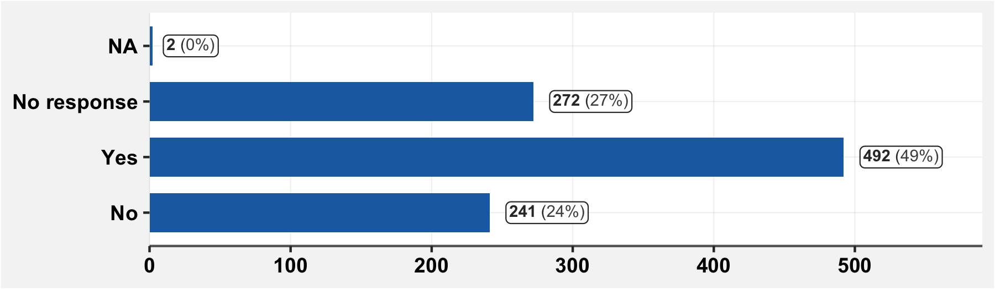

## 14.3 Since March 1st, have you noticed an increase in stress for yourself or in your household, connected with the epidemic?

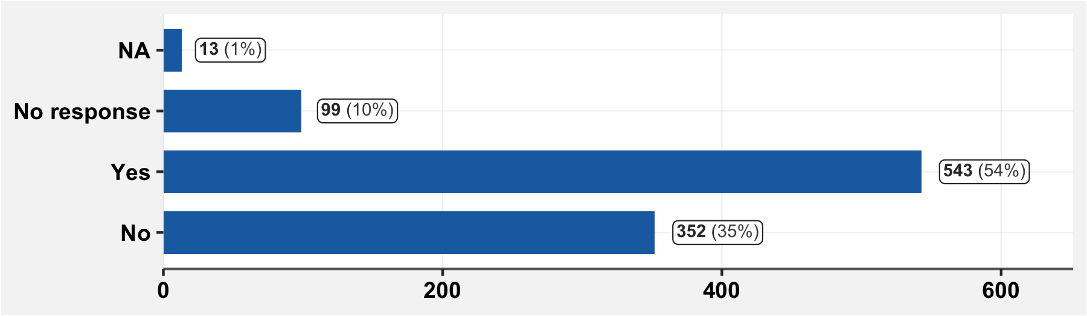

## 14.4 Within your household, have you faced since March 1st any physical or psychological violence?

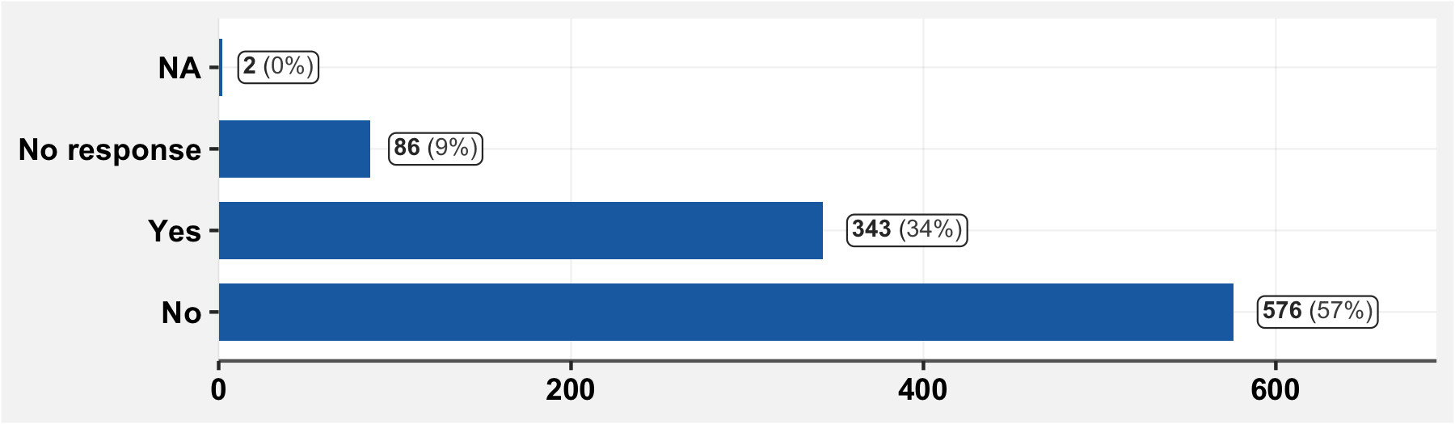

## 14.5 Since March 1st, have you received any material aid (money, meals, …) from external sources?

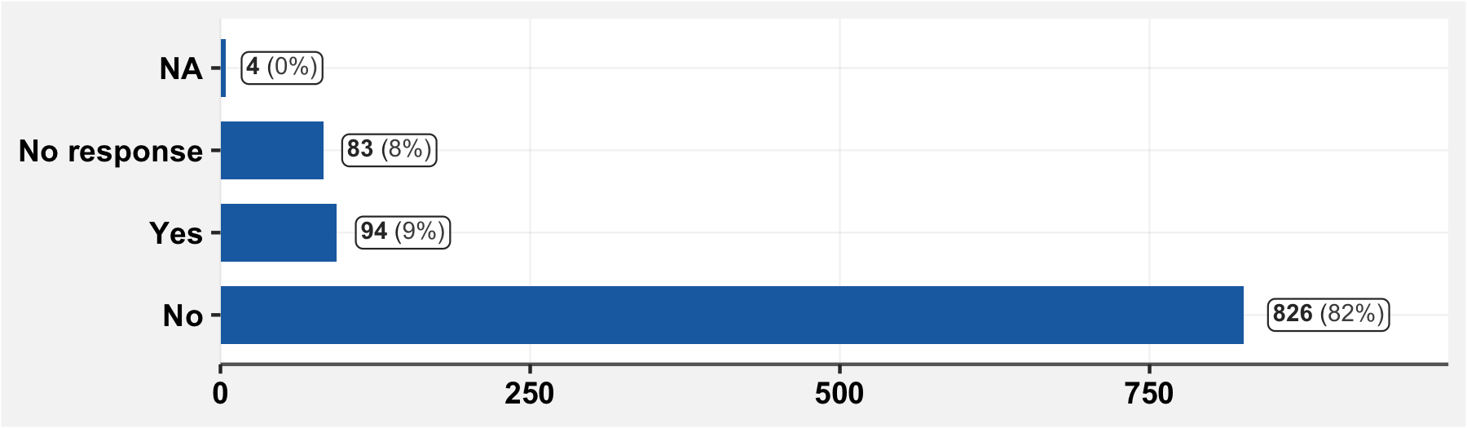

## 14.5.1 Specify the received items

(free response)

|  |  |  |  |
| --- | --- | --- | --- |
| **Item received** | **n** | **Item received** | **n** |
| Argent | 17 | Repas, Savons | 1 |
| Savons | 8 | Repas,Argent | 1 |
| Repas | 5 | Repas,Desinfectants,Cache Nez,Argent | 1 |
| Riz,Huile | 4 | Riz ,Huile | 1 |
| Nourriture | 3 | Riz Huile | 1 |
| Argent, Repas | 2 | Riz, Savon, Bidon, Seau | 1 |
| Cache Nez | 2 | Riz,Huile Sucre Et Masques | 1 |
| L'argent | 2 | Savon Bidon | 1 |
| Savon | 2 | Savon Bidon | 1 |
| Savons Et Repas | 2 | Savon , Cache Nez , | 1 |
| Aide Financiere | 1 | Savon , Seau | 1 |
| Argent Et Repa | 1 | Savon Bidon | 1 |
| Argent Et Repas | 1 | Savon Cache Nez | 1 |
| Argent Repas | 1 | Savon Gel Produits Alimentaires Masques | 1 |
| Argent, Nourriture | 1 | Savon Masque | 1 |
| Bidon Savon | 1 | Savon, Cache Nez | 1 |
| Cache Nez , Savon, Bidon | 1 | Savon, Seau, | 1 |
| Cache Nez ,Seau,Savons | 1 | Savon,Bidon,Seau | 1 |
| Cache Nez Savons | 1 | Savon,Riz | 1 |
| Cache Nez, Desinfectant, | 1 | Savon,Seau | 1 |
| Financier | 1 | Savons Et Seau | 1 |
| Financiere | 1 | Savons,Cache Nez | 1 |
| Gels Hydroalcoolique | 1 | Seau Robinet, Savon, Cache Nez | 1 |
| Materiel | 1 | Seau Savon | 1 |
| Medicaments | 1 | Seau,Cache Nez | 1 |
| Nourriture Crue | 1 | Seau,Savon, | 1 |
| Nourriture,Savon | 1 | Seaux Et Savons | 1 |
| Repas, Argent | 1 | Tante | 1 |

## 14.5.2 If, since March 1st, you have received material aid from external sources, indicate which

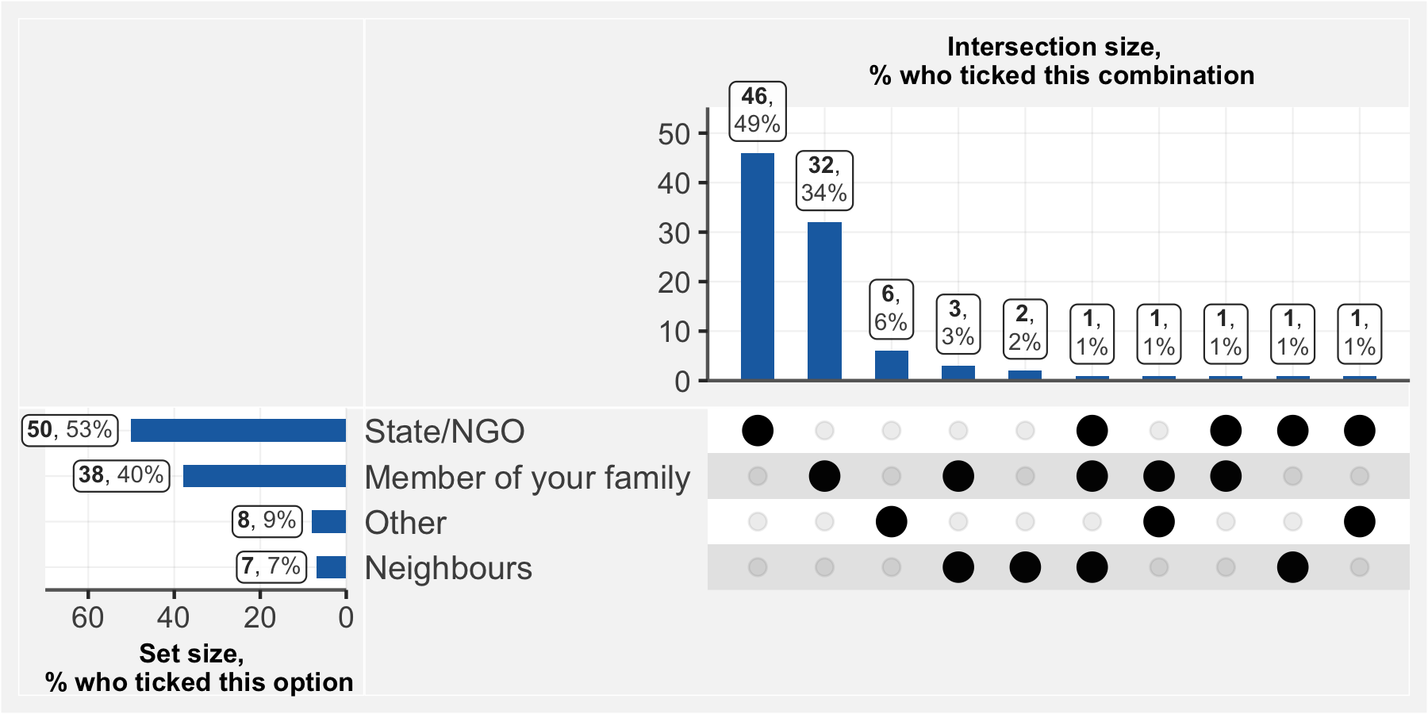

## 14.5.2.1 If you responded “other” to the previous question, specify

|  |  |
| --- | --- |
| **Help Source** | **n** |
| Ami | 1 |
| Amis | 1 |
| Communaute Chretienne | 1 |
| Communaute Musulmane, Ami | 1 |
| Eglise | 1 |
| Mairie Yde 2 | 1 |
| Restaurant | 1 |
| Service | 1 |

## 14.5.3 If, since March 1st, you have received external material aid, at what frequency has this come, compared with before the pandemic?

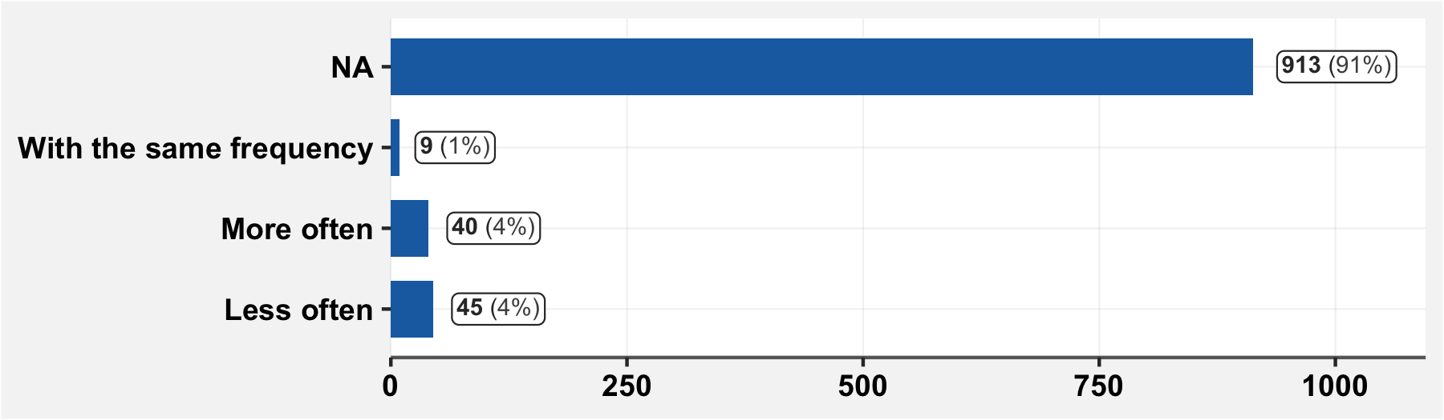

# 15 Screening done during the survey visit

## 15.1 Do you currently have one or several of the following symptoms?

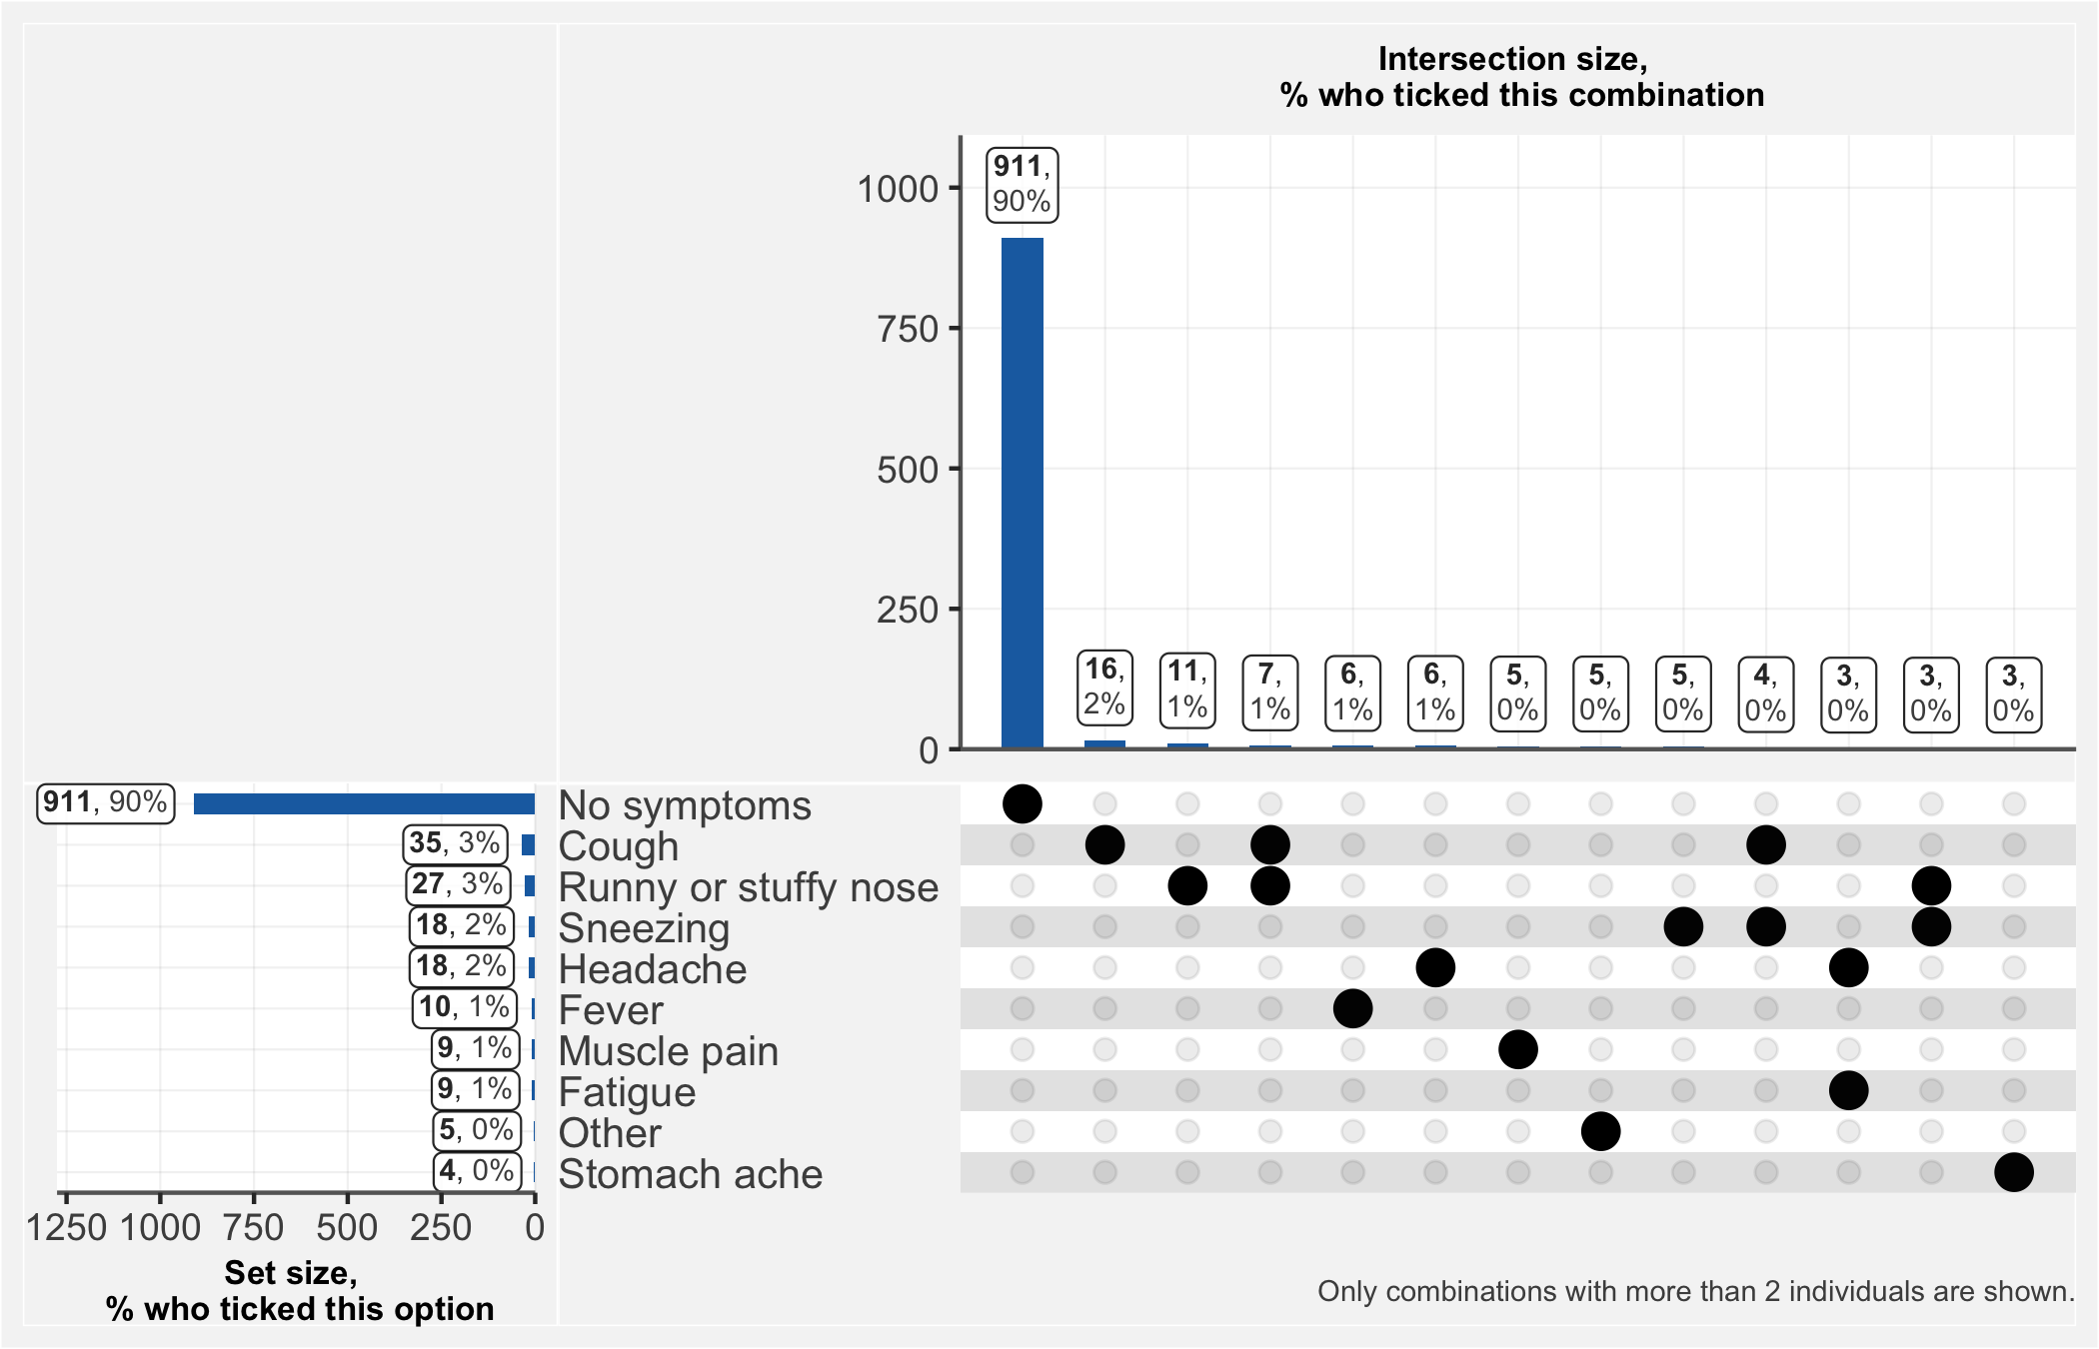

## 15.1.1 If you answered “Other” to the previous question, specify

|  |  |
| --- | --- |
| **Additional Symptom** | **n** |
| Douleurs Oculaires | 1 |
| Mal De Dos | 1 |
| Mal De Yeux | 1 |
| Maux De Ventre | 1 |
| Vertige, Douleurs Lombaires | 1 |

## 15.2 Oxygen saturation

“To be measured in case of COVID-like symptoms. Express as a percentage”

|  |  |
| --- | --- |
| **OXygen Saturation** | **n** |
| 97 | 5 |
| 96 | 6 |
| 93 | 1 |
| 91 | 1 |

## 15.3 Breathing rate

“To be measured in case of COVID-like symptoms. Express as number of breaths per minute”

|  |  |
| --- | --- |
| **Breathing Rate** | **n** |
| 37 | 1 |
| 35 | 1 |
| 30 | 1 |
| 26 | 1 |
| 25 | 1 |
| 23 | 2 |
| 20 | 3 |
| 19 | 1 |
| 18 | 1 |
| 17 | 1 |
| 16 | 1 |
| 15 | 4 |

# 16 Test done during the survey visit

## 16.1 Serologic test (whether or not carried out)

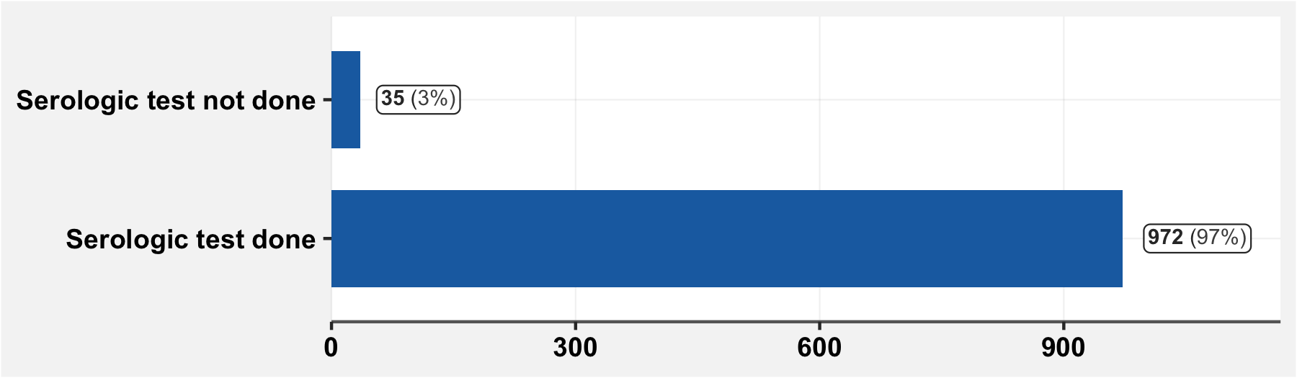

## 16.1 If the serologic test was not done, specify why

|  |  |
| --- | --- |
| **Reason** | **n** |
| refus | 28 |
| enfant réticent | 2 |
| enfants endormi | 1 |
| la peur du resultat | 1 |
| refus , peur du résultat, voyage pour l'étranger en cours | 1 |
| refus pour avoir déjà fait frottis | 1 |
| vient de faire | 1 |

## 16.1.1 IgG test result

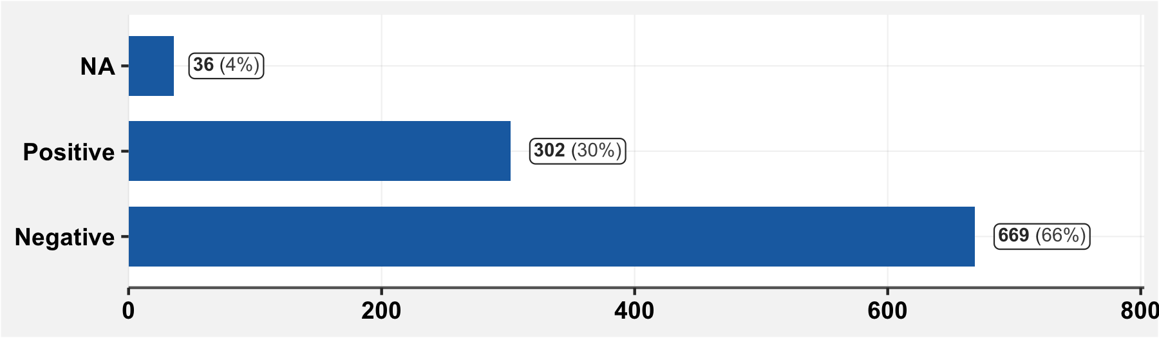

## 16.1.1 IgM test result

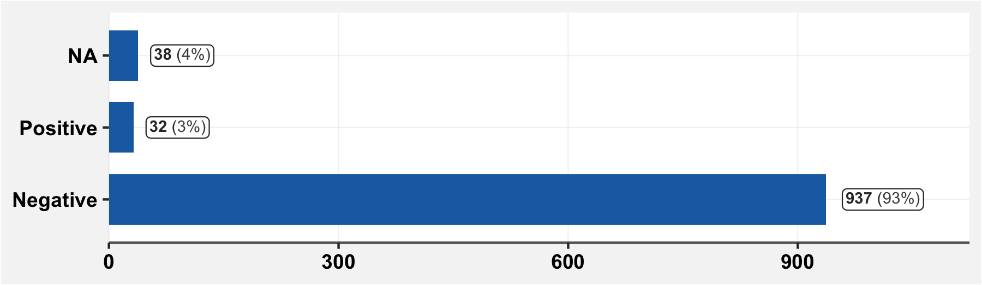

## 16.2 Was a sample taken for the antigen test?

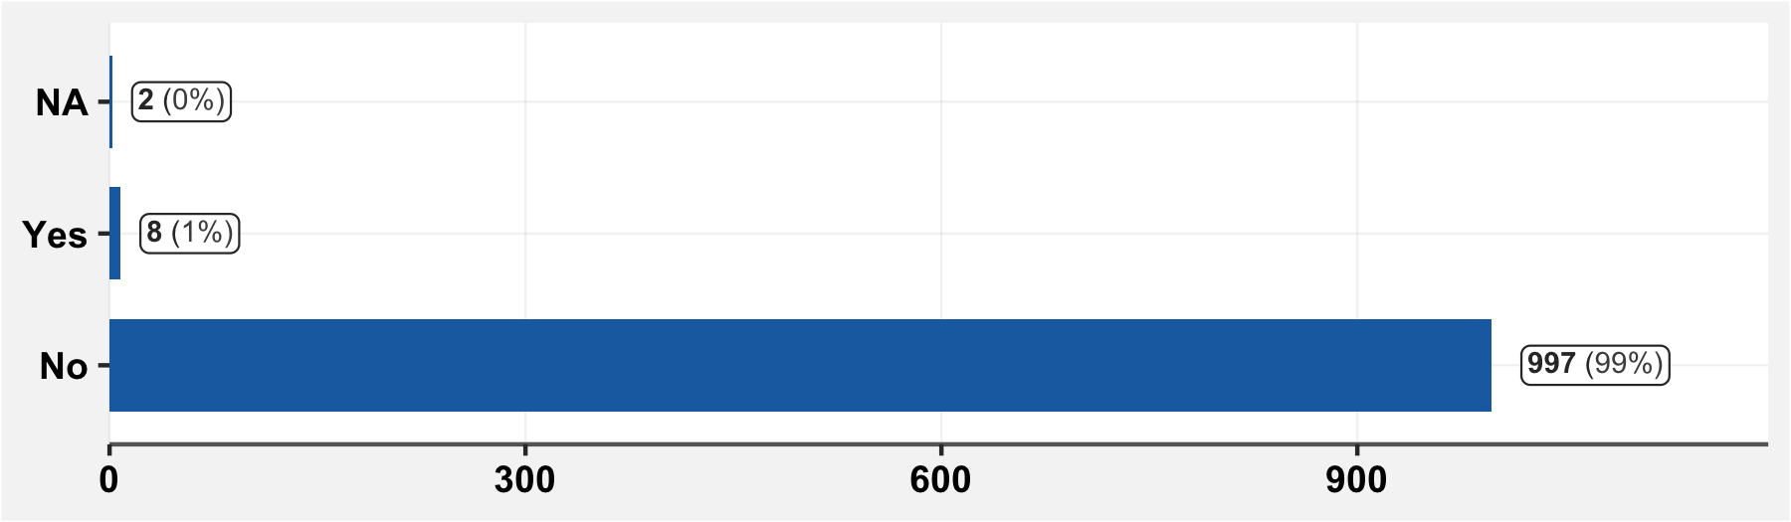

## 16.2.1 If the antigen test was not done, specify why

|  |  |  |  |
| --- | --- | --- | --- |
| **Reason** | **n** | **Reason** | **n** |
| non suspect | 440 | igg negatif (asymptomatique) | 1 |
| pas de suspicion | 163 | igm | 1 |
| no suspect | 117 | les resultats negatifs | 1 |
| cas no suspect | 61 | no suspect et refus | 1 |
| non suspicion du covid | 57 | no suspicion | 1 |
| asymptomatique | 52 | no suspicion du covid | 1 |
| test serologique negatif | 31 | non suspect c | 1 |
| igm negatif | 12 | non suspicion covid | 1 |
| refus | 9 | non suspicion du clovis 19 | 1 |
| igg negatif | 8 | pas de | 1 |
| non suspicion du clovis | 6 | pas de suspicion | 1 |
| tdr negatif | 5 | pas de suspicions | 1 |
| pas suspect | 4 | pas de symptomes | 1 |
| non | 3 | pas suspct | 1 |
| non suspect | 3 | pas suspicion | 1 |
| non suspicion | 3 | personne no suspecte | 1 |
| tdr negatif | 3 | sero no faite | 1 |
| cas no supect | 1 | symptomes reguliers chez la patiente quand elle a la grippe | 1 |
| cas suspect | 1 |  |  |

## 16.2.1 Result of the antigen test

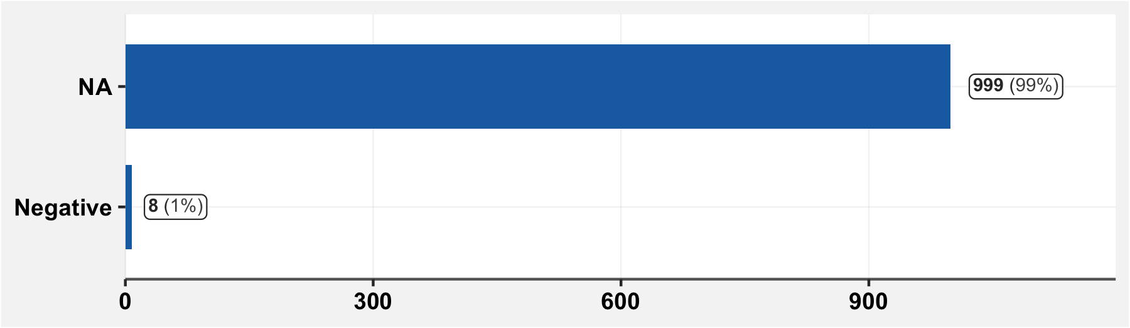

## 16.3 Was a sample taken for the PCR test?

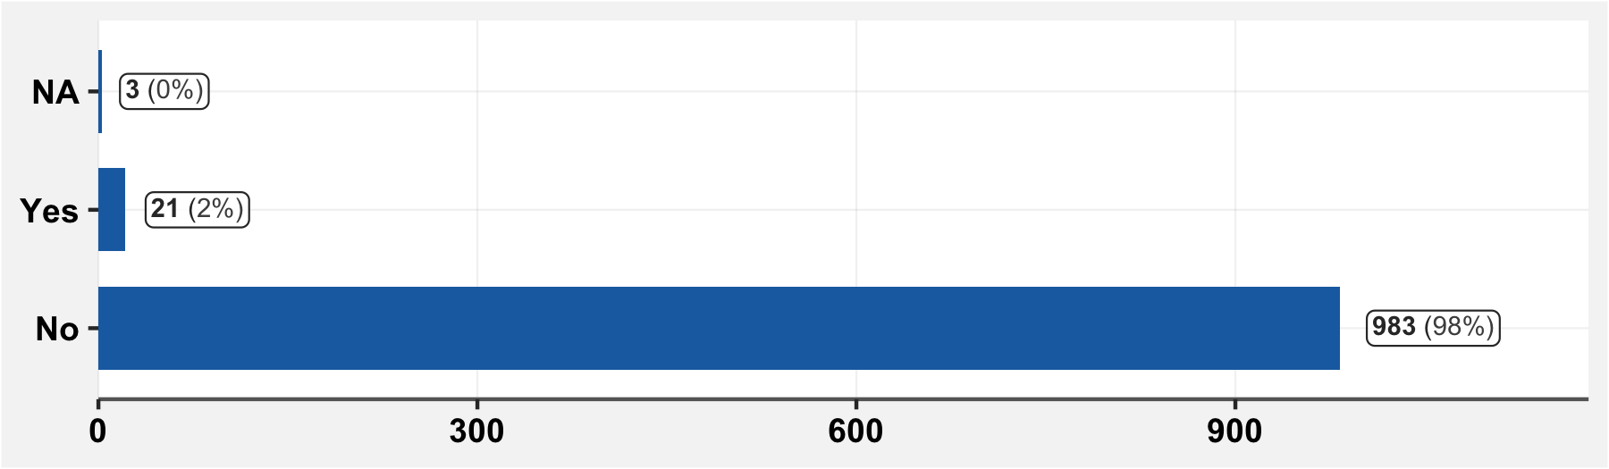

## 16.3.1 If the PCR test was not done, specify why

|  |  |  |  |
| --- | --- | --- | --- |
| **Reason** | **n** | **Reason** | **n** |
| igm negatif | 732 | igg+ | 1 |
| repondant asymptomatique | 36 | igm et igg negatif | 1 |
| tdr negatif | 29 | igm negatif , et refus pour raison de sinusite et rappel de la gene du dernier prelevement | 1 |
| igg et igm negatifs | 28 | igm negatif et repondant asymptomatique | 1 |
| igm - | 16 | igm negatif et tdr antigene negatif | 1 |
| refus | 14 | igm negatif sur test 0005 | 1 |
| asymptomatique | 13 | igm negatif test 2 | 1 |
| igg positifs et igm negatifs | 9 | igm negative | 1 |
| inapproprie | 9 | igm no connus | 1 |
| igg negatif | 7 | igm+ | 1 |
| igm | 7 | inaccessible | 1 |
| no suspect | 7 | innaproprie | 1 |
| igm neg | 6 | no suspect et refus | 1 |
| test serologique no fait | 6 | non fait | 1 |
| igm- | 5 | nrp | 1 |
| tdr | 5 | ogm negatif | 1 |
| igg et igm negatif | 3 | oubli | 1 |
| igm negatifs | 3 | pas coherent | 1 |
| non suspect | 3 | pas de suspicion | 1 |
| igm et igg negatifs | 2 | refuse | 1 |
| inappropriee | 2 | repondant asymptomatique et test serologique negatif | 1 |
| serologie no fait | 2 | repondant sans symptomes evocateurs du covid | 1 |
| enfant asymptomatique | 1 | repondante asymptomatique | 1 |
| ig g negatif | 1 | resultats negatifs | 1 |
| ig m - | 1 | sero no faite | 1 |
| ig m negatif | 1 | tdr negatif repondant asymptomatique | 1 |
| igg igm negatif | 1 | test serologie negatif et repondant asymptomatique | 1 |
| igg igm negatifs | 1 | test serologie no fait | 1 |
| igg positifs igm negatif | 1 | test serologique negatif | 1 |

## 16.3.1 Result of the PCR test

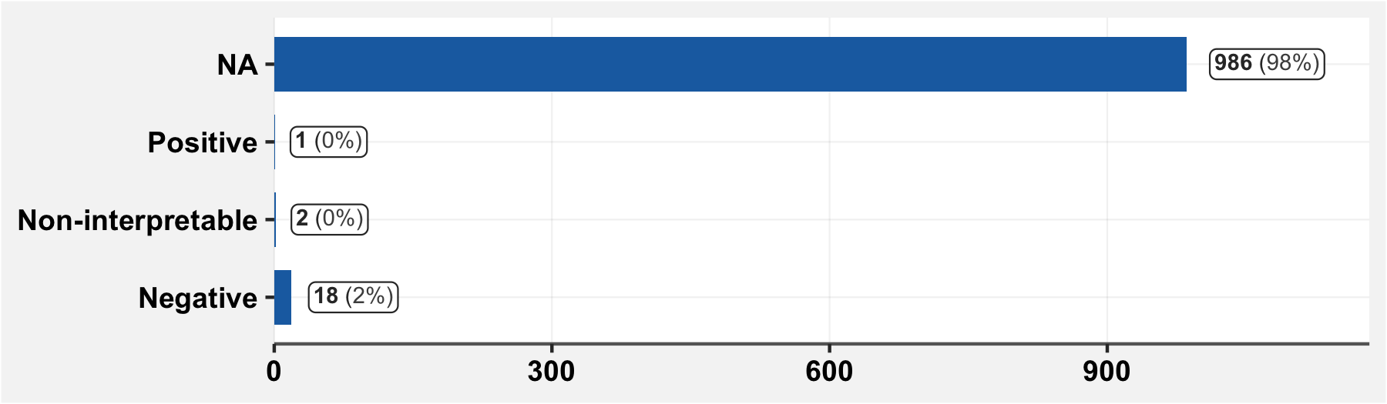

# 17 Recommendations to people with symptoms

